**Data Visualization:**

**Activity 4.1**

**Ganesh Gundekarla**

**Task 1 :**

**Step 1 :** We have connected the sample superstore file and connected to it in the Tableau app.

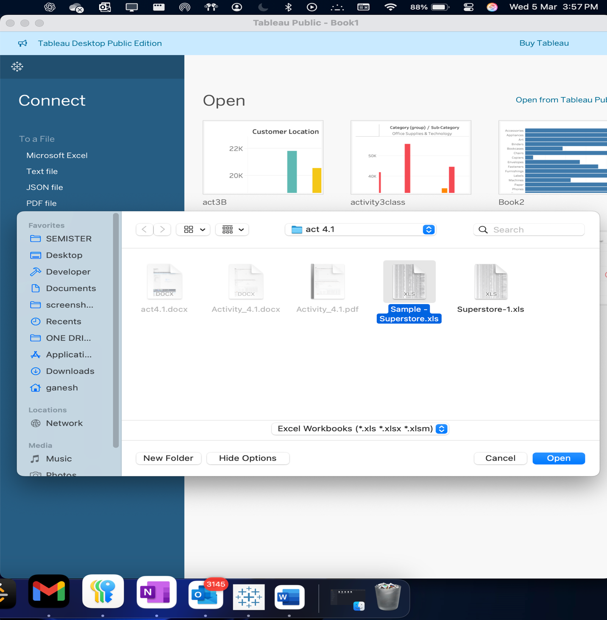

Step 2 and step 3: selecting the Orders from the imported excel file.

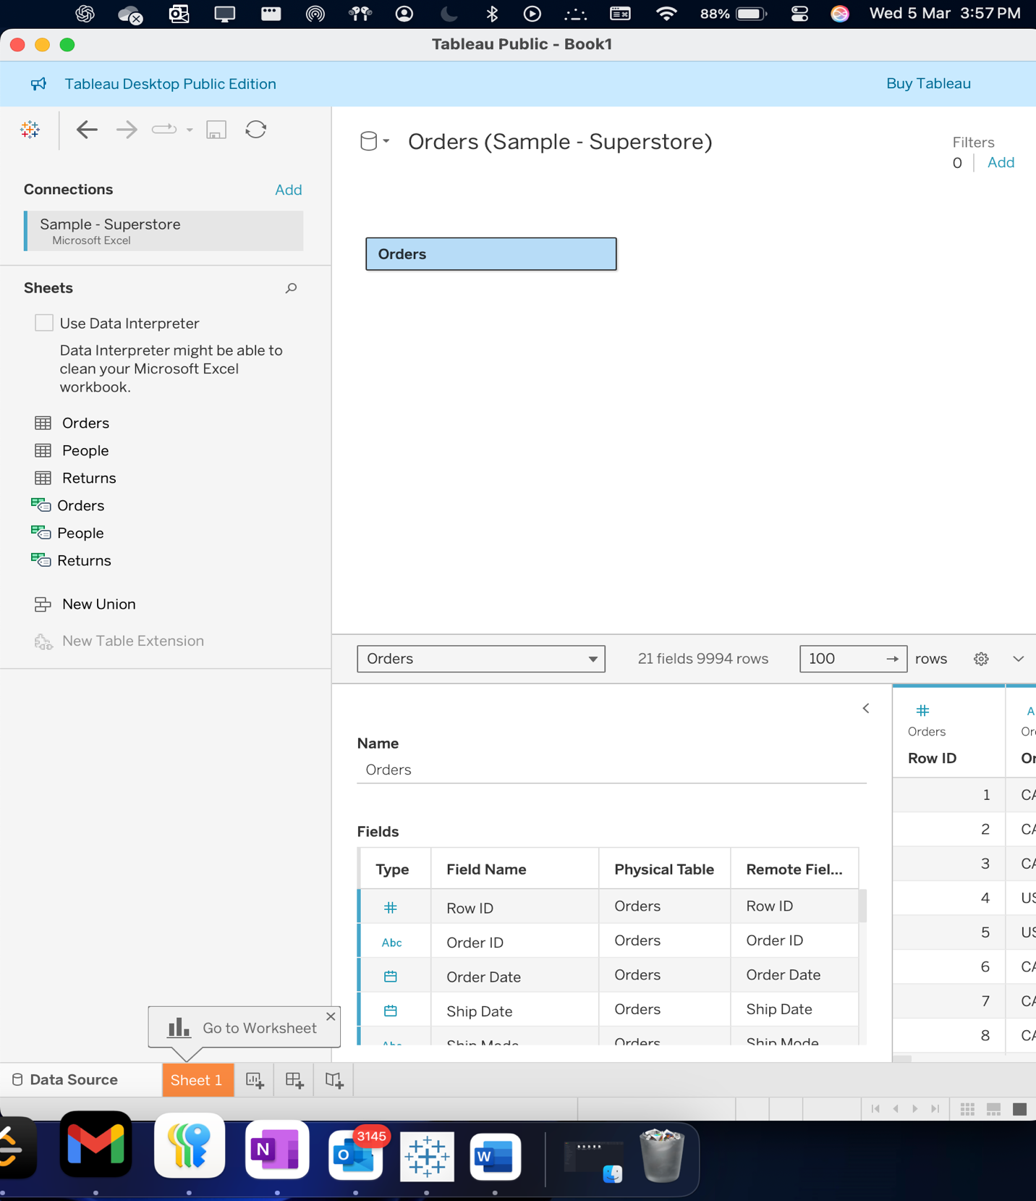

Step 4 : Dragging of the returns table and placing it beside Orders in order to draw relationships.

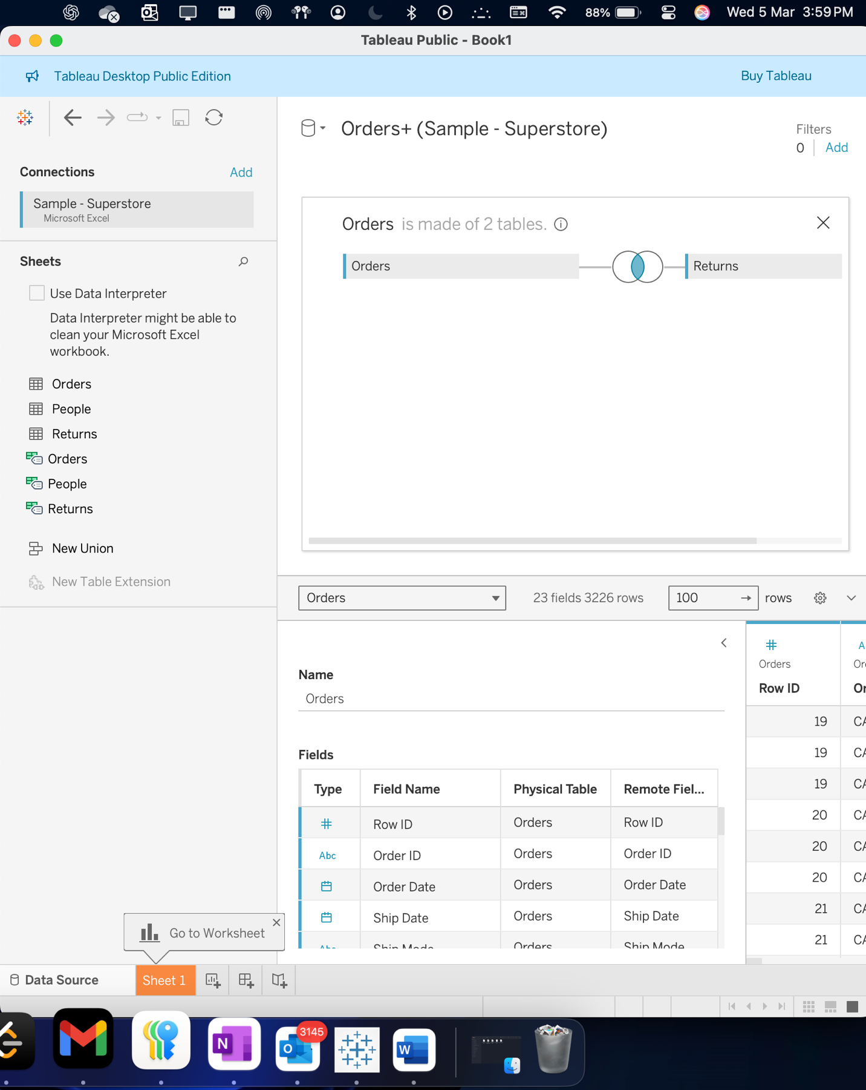

Step 5 : Join configuration using the tableau where we can select left join or the right ones or total .

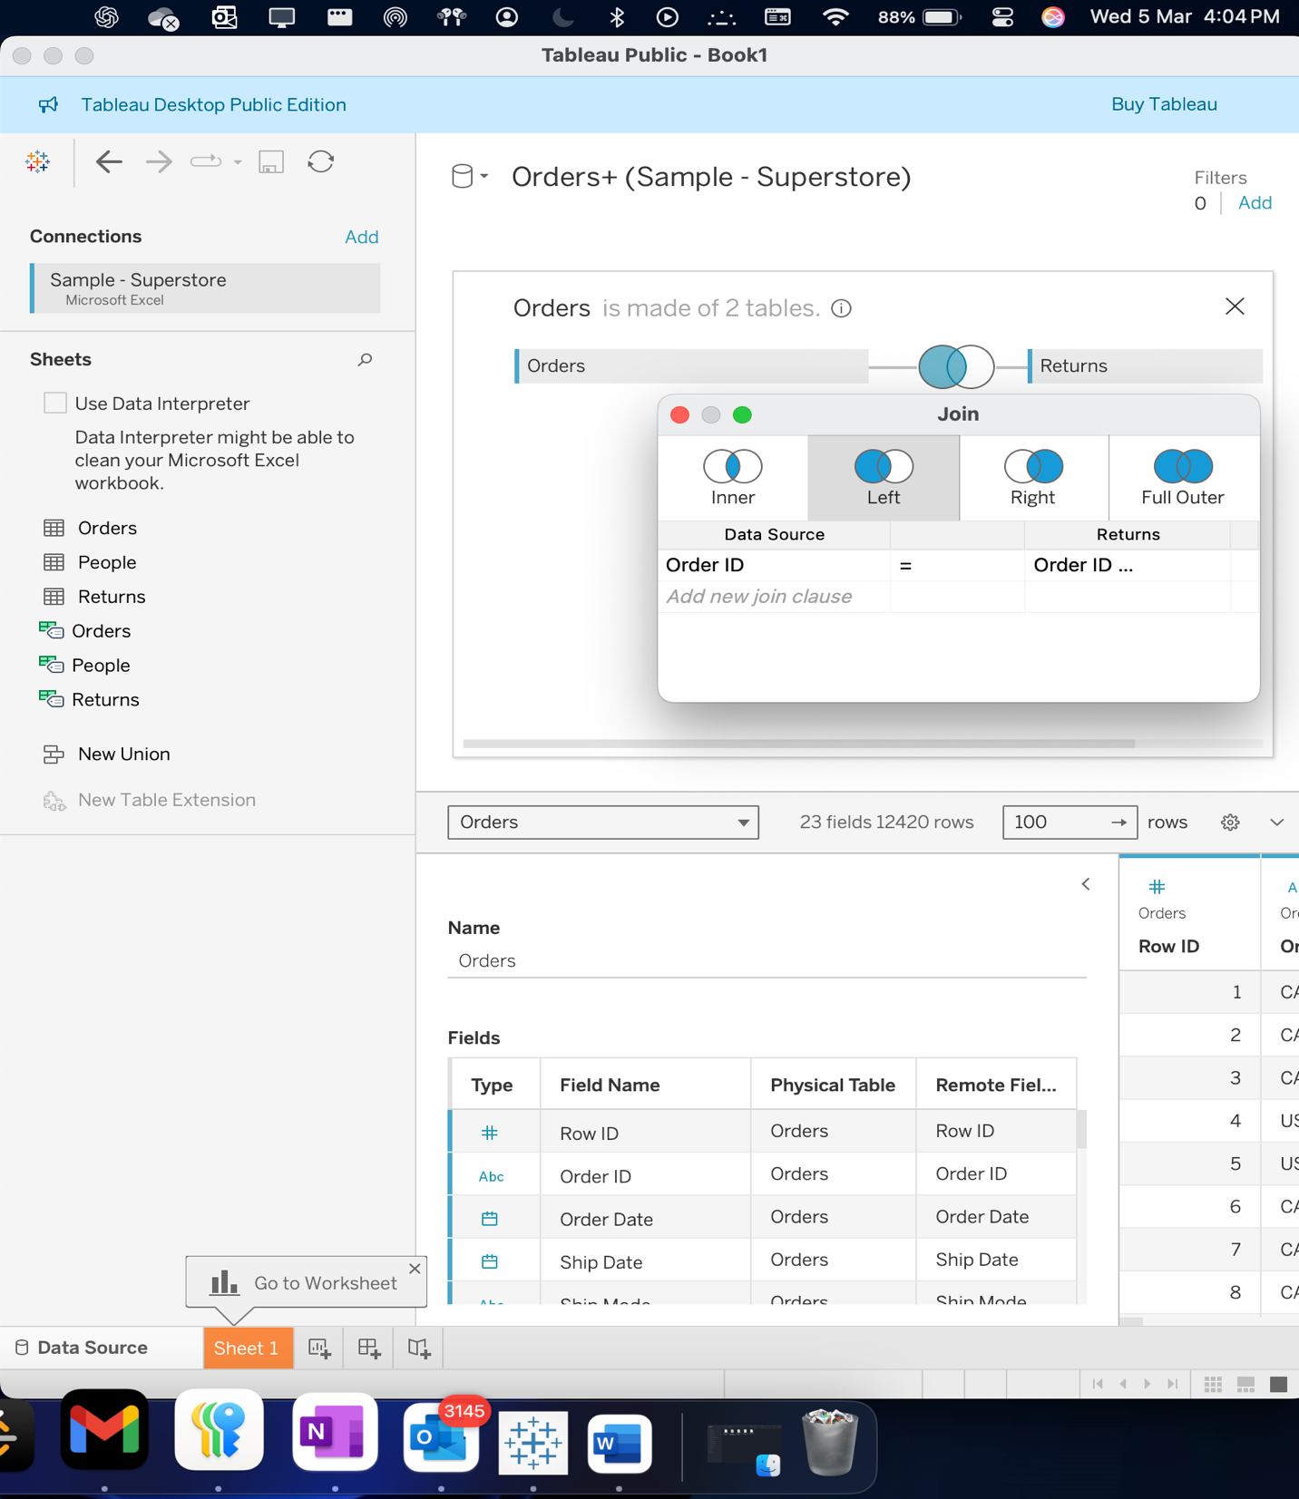

Step 6 : performing visualizations in the sheet one where each color will be representing us the different sub category of the products.

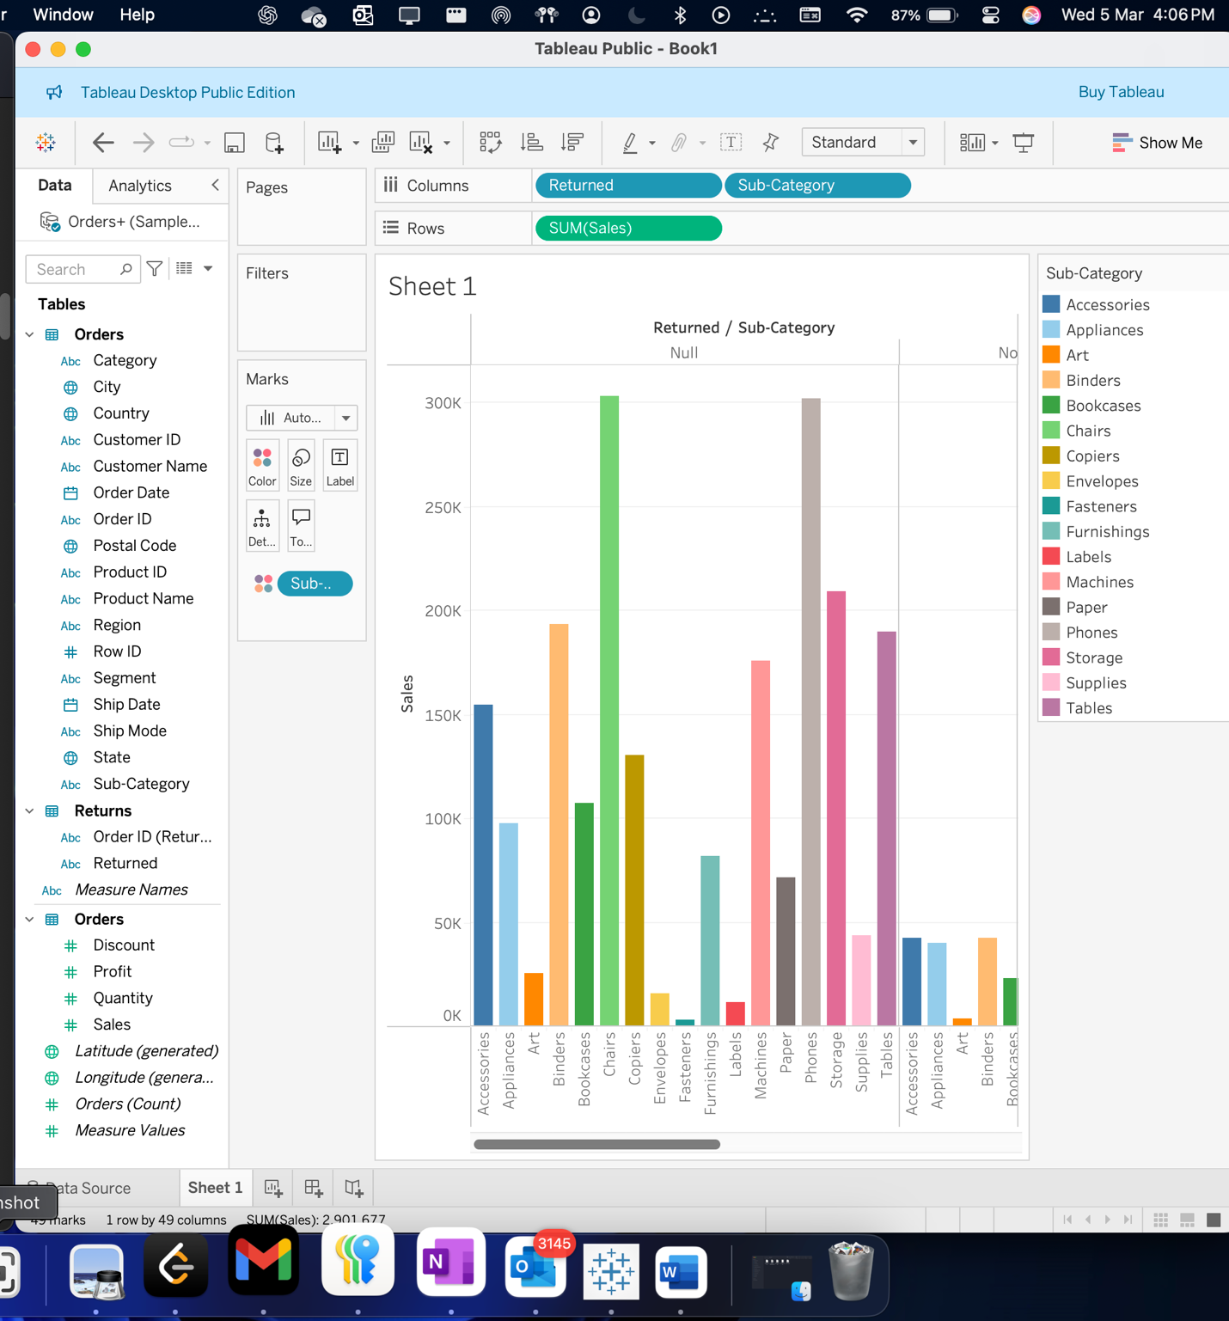

Step 7. : Performing a inner join from the orders and the people tables and selecting the inner join.

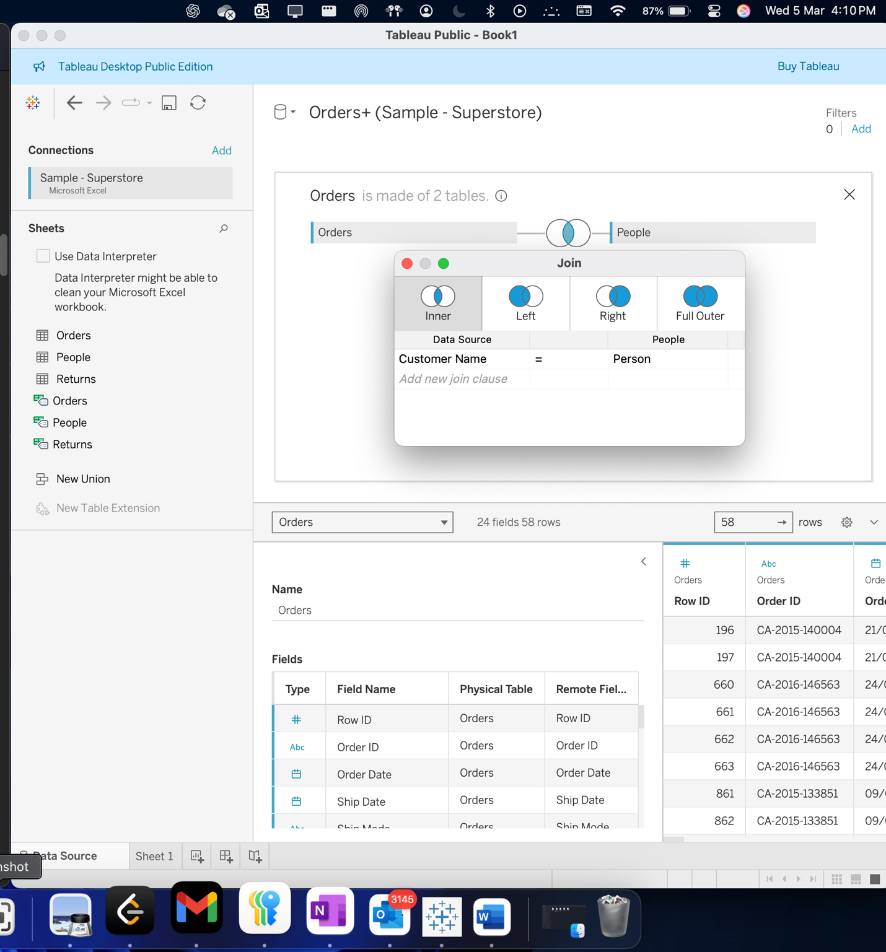

Step 8 : building the visualization on sheet 2 :

Here, the visualization basically displays us the total number of sales which are being divided into different sub categories and then it is categorized or being visualized using each persons type. So , the stacked bar graph here basically represents us the sum of total sales on each different sub category .

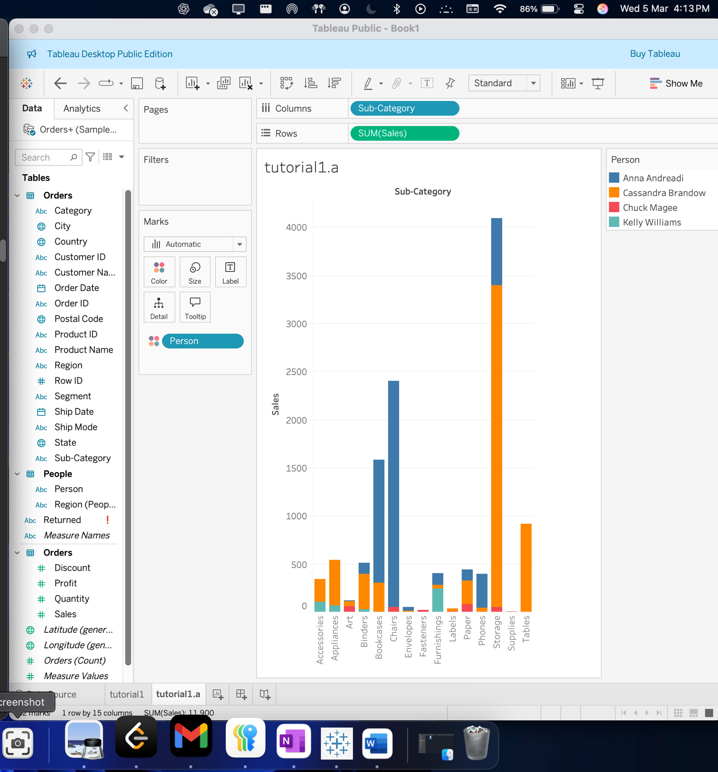

Question 1 :

When performed inner join between two tables .

Visualization :

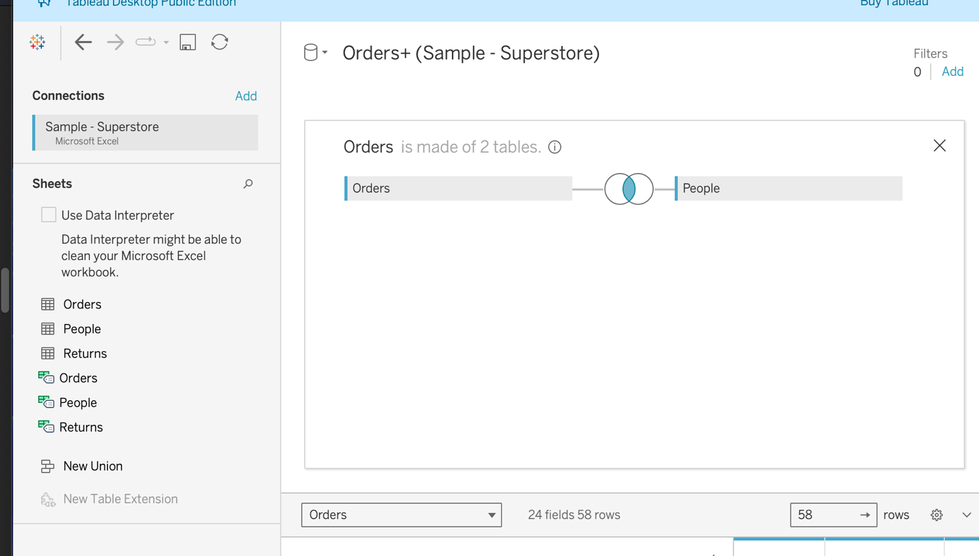

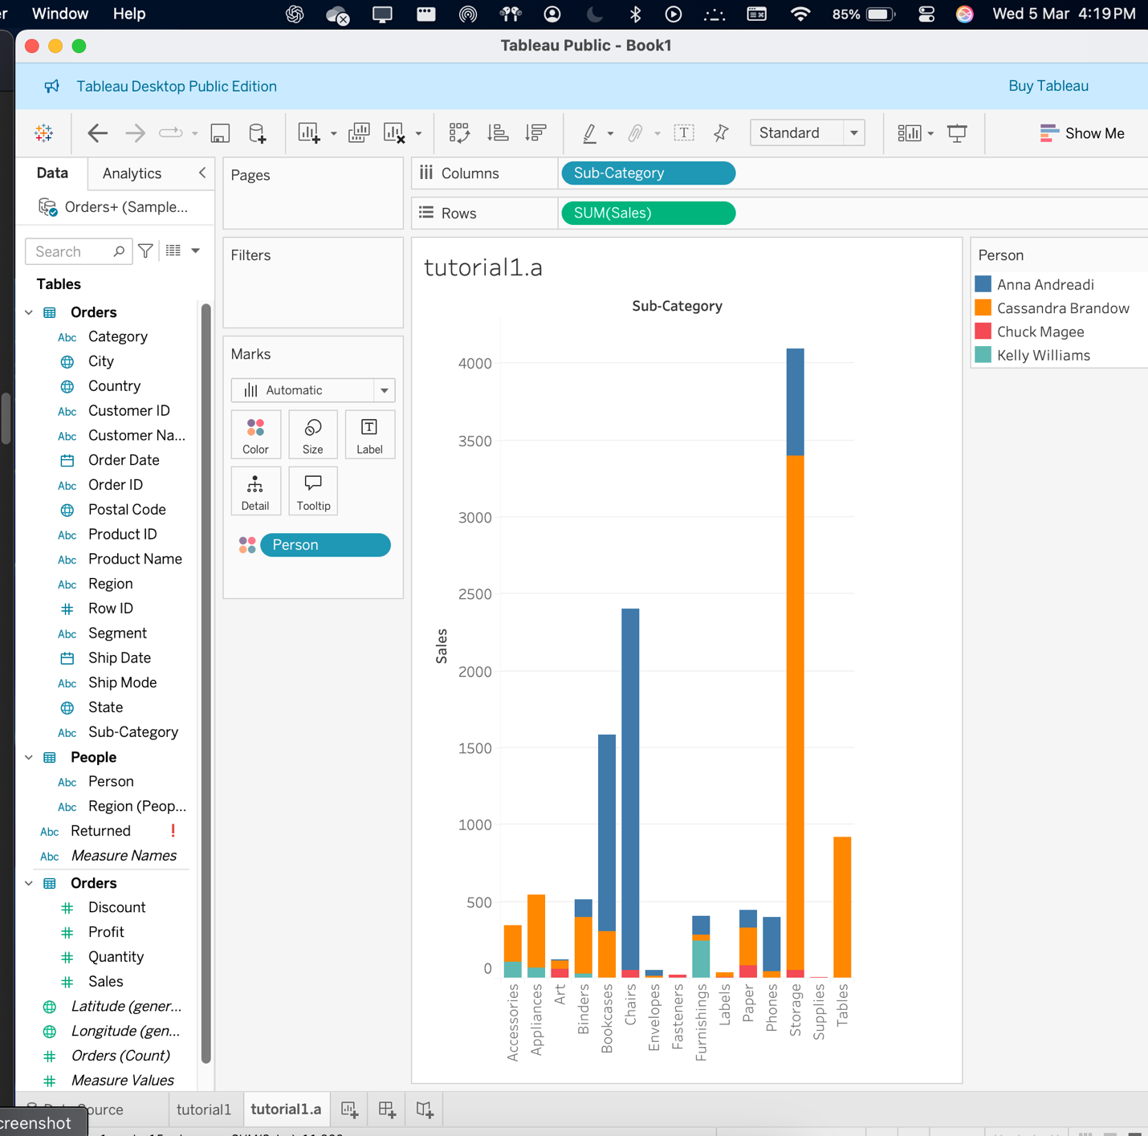

Let us perform full outer join :

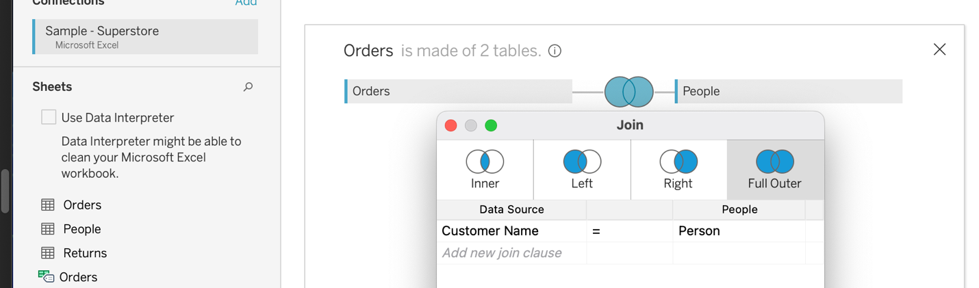

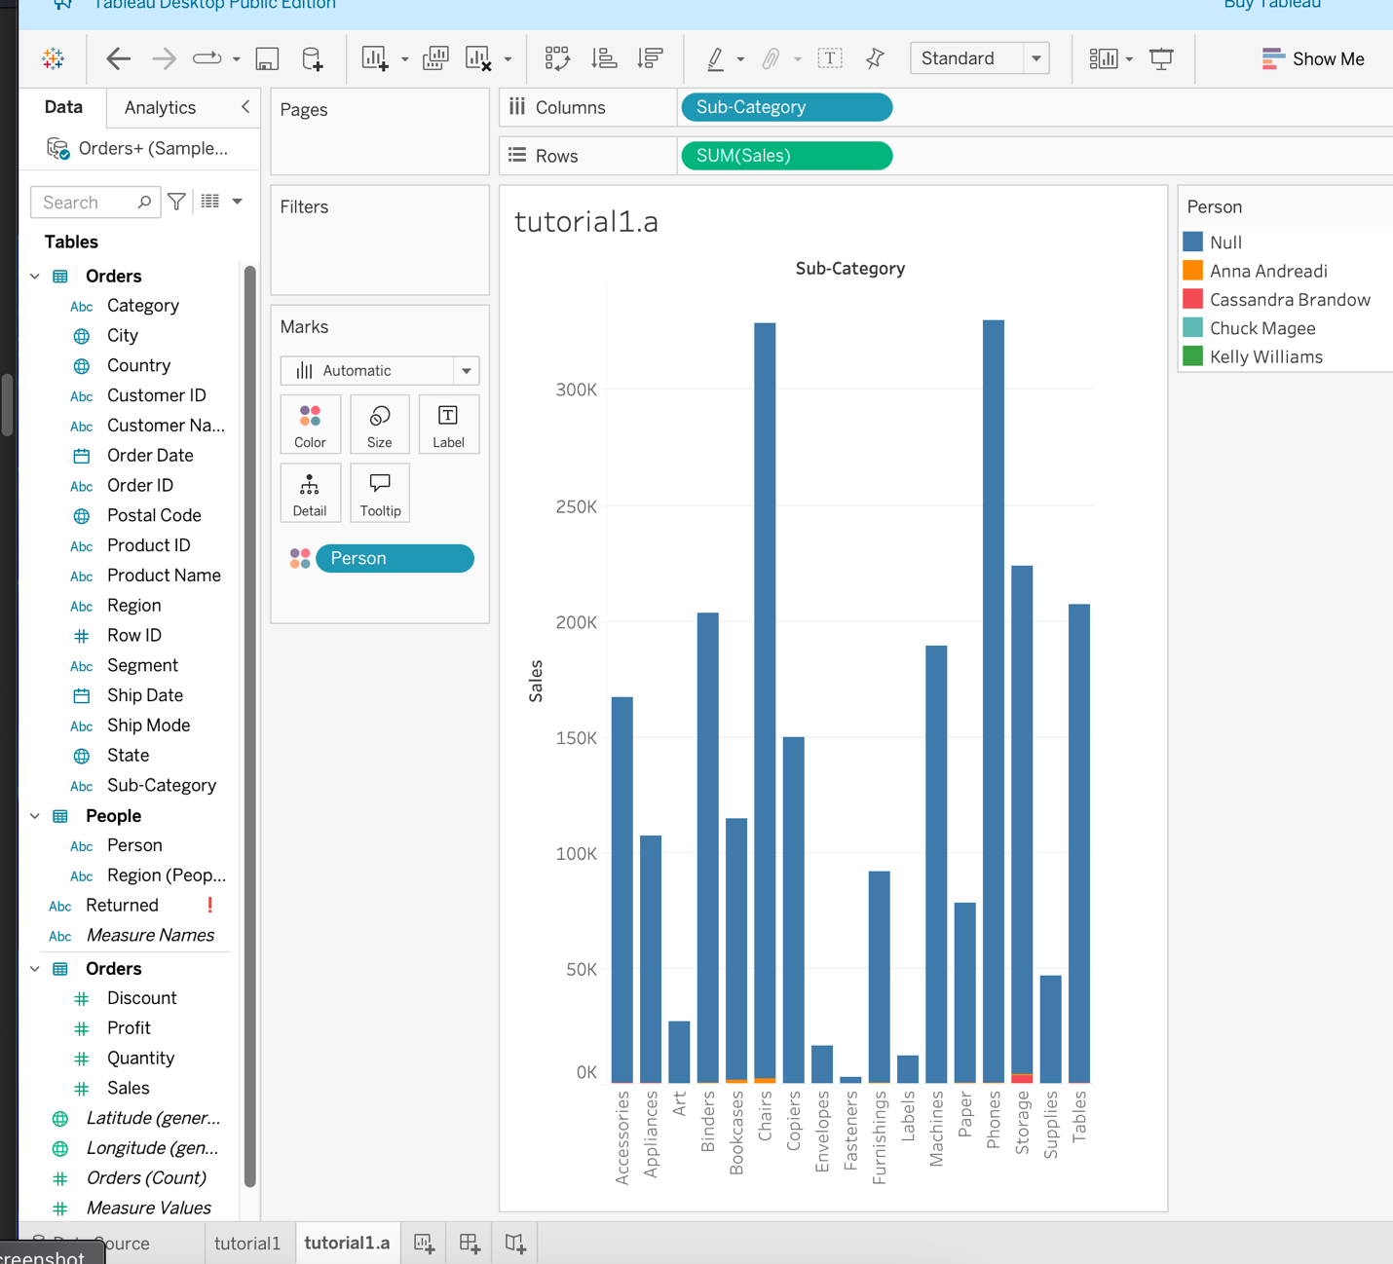

Impact of joins in tables and their impact on visualizations :

Here , joins in tables are based on the columns of the table and joins are performed on required ones. So , the choice of the join type will greatly effect the results as the whole table gets altered depending on the join we had performed .

1. Inner join : this is a middle join which focuses only on the common data and the other un remained data will be omitted.
2. Resulting dataset will be smaller but more accurate and corrective.

C : **left join** will be keeping most of the data on the left table and the dataset will be comprised much from the left table and the columns common with the right table.

Impact on the visualization : Here , dataset will be a bit bigger , with less unmatched records also present , if the resulted ones have ‘null’ values , then this will result us in incorrect visualizations / some empty spots / some inaccuracies.

D : RIGHT JOIN : Similar to the left join , but this appears in reverse as , most of the data basically is disappeared from the left table this time .

E : Full outer join : Full outer join will be resulting us the largest dataset as it will combine everything from two tables. Null values will be appearing from both tables and more frequent values and this will lead to incomplete bars or missing data points.

So , this is how dataset’s get affected impacting the overall visualization .

Task 2 :

Step 1 : loading up the tableau application and connecting it with ‘superstore’ file in the data source .

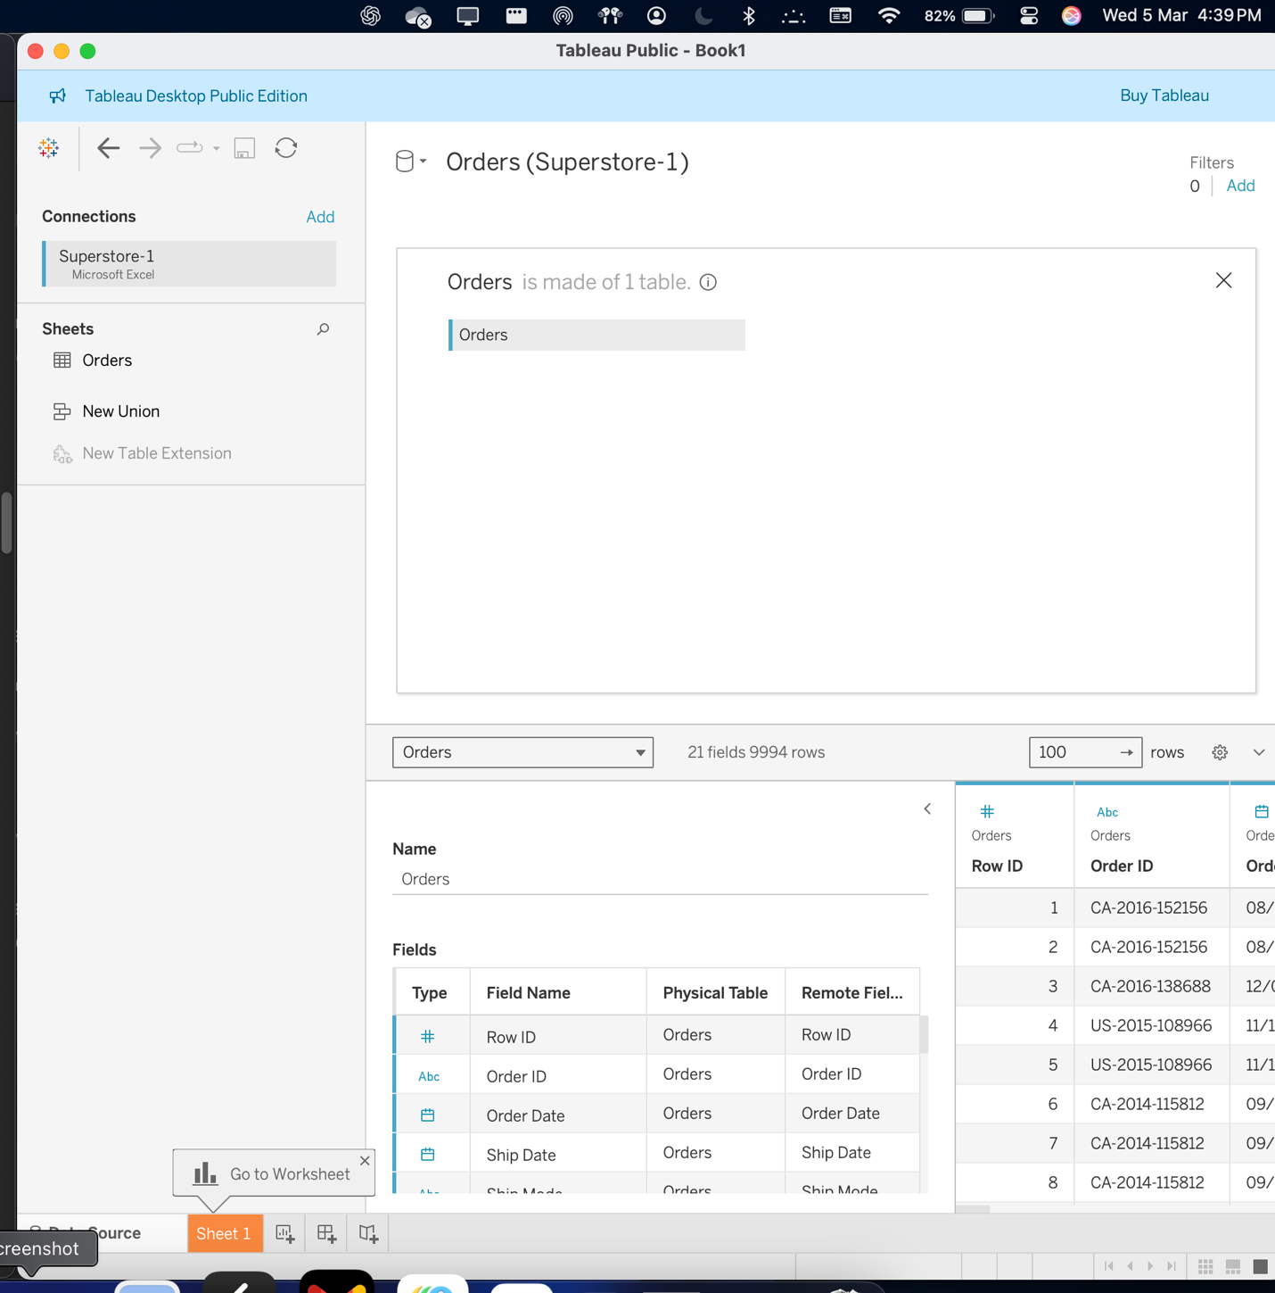

Step 2 :

Creating a parameter and creating it using specific values.

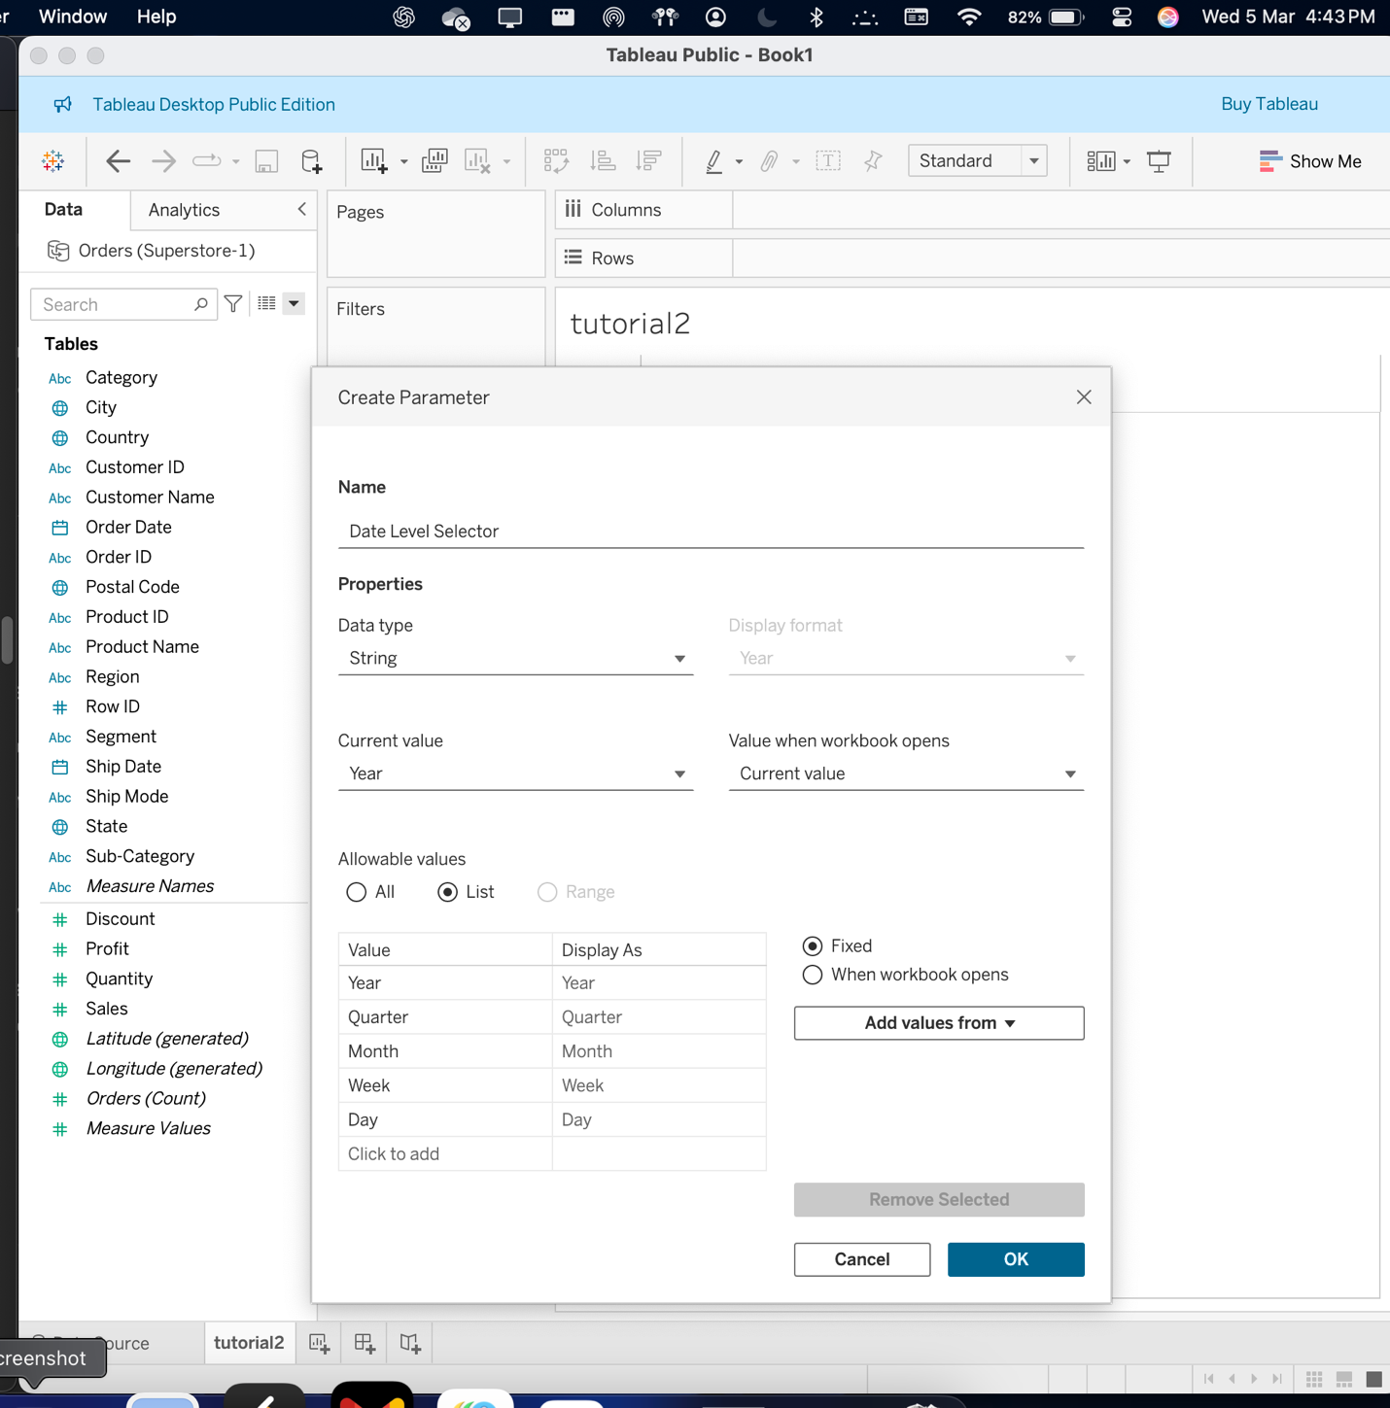

Step 4 : viewing the parameter under the parameters section .

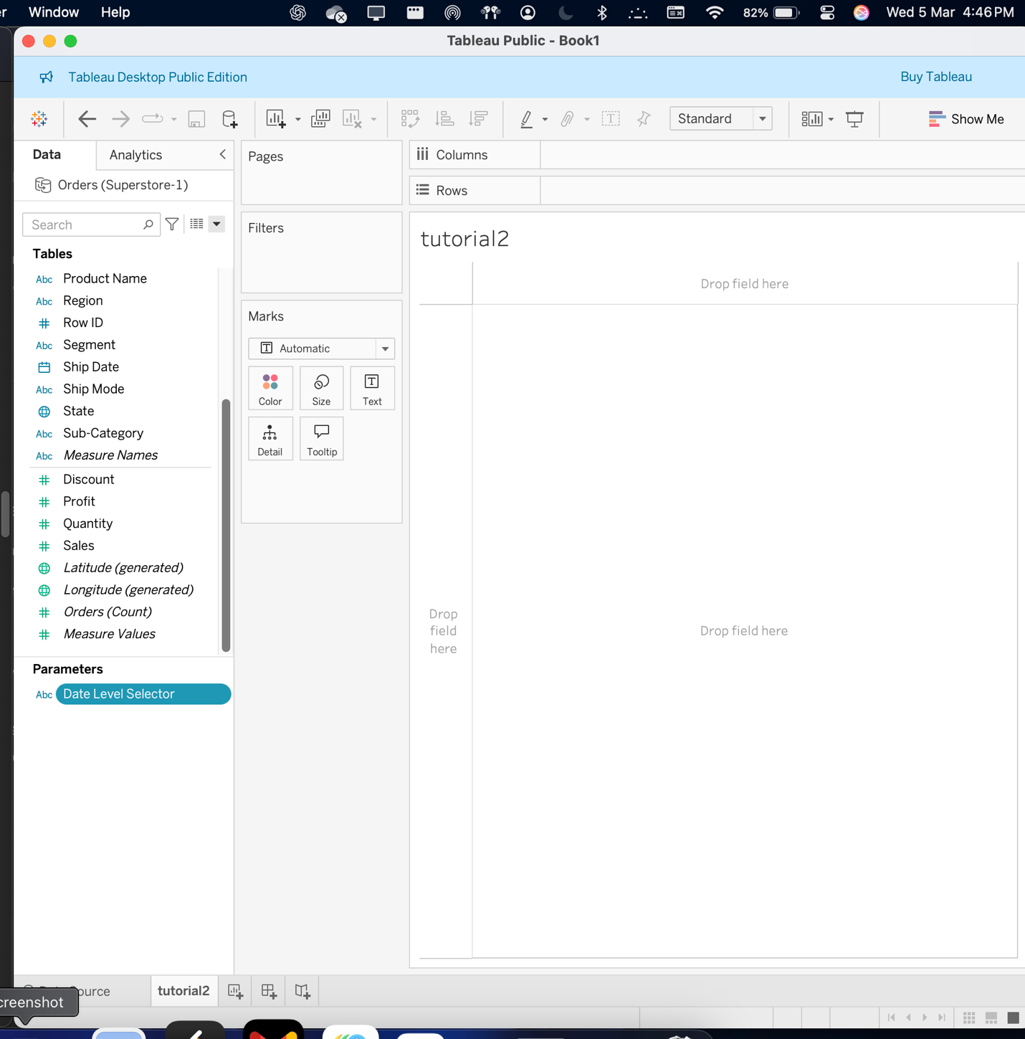

Step 5 : creating a new calculated field and naming it as date selector .

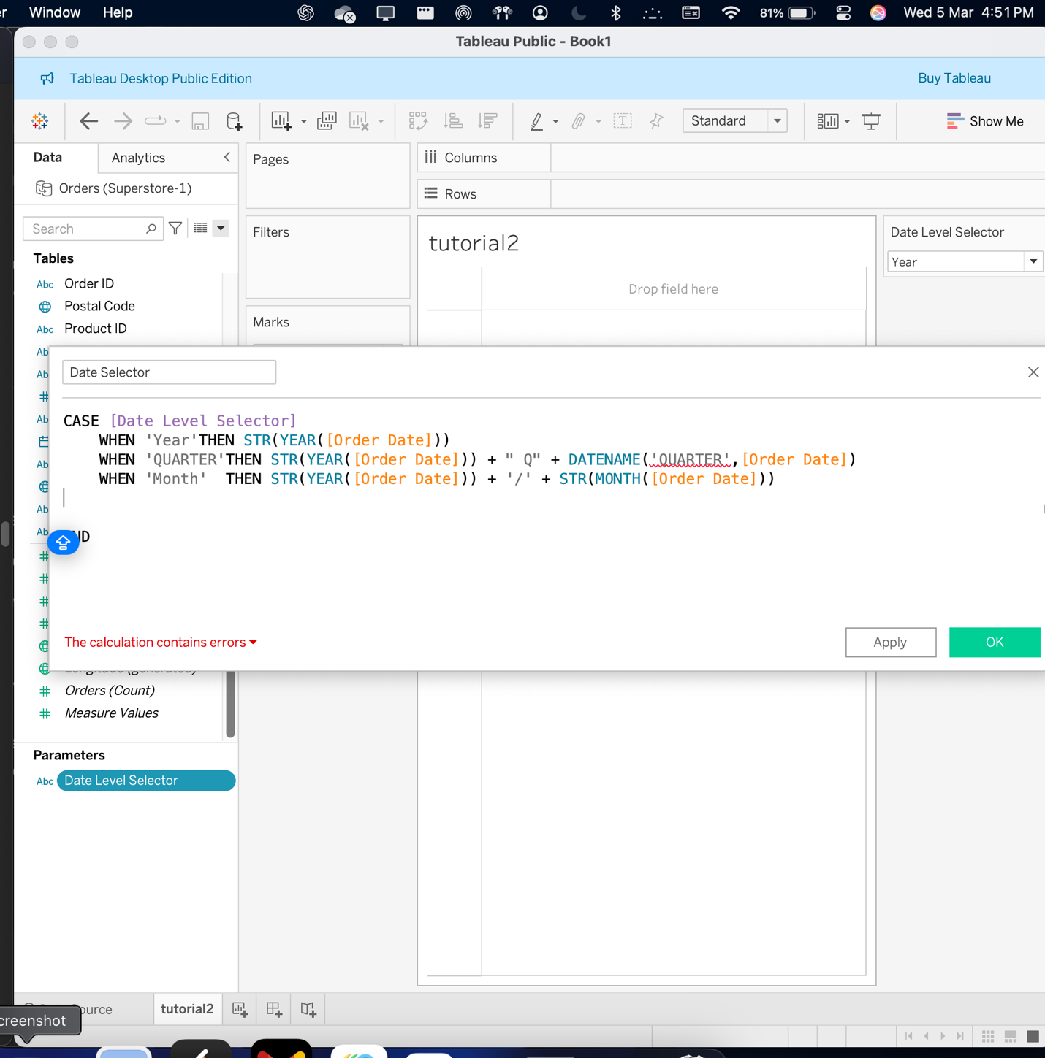

Step 6 : visualization of the sales data.

Dragging the required attributes in order to create a visualization to display the sales data.

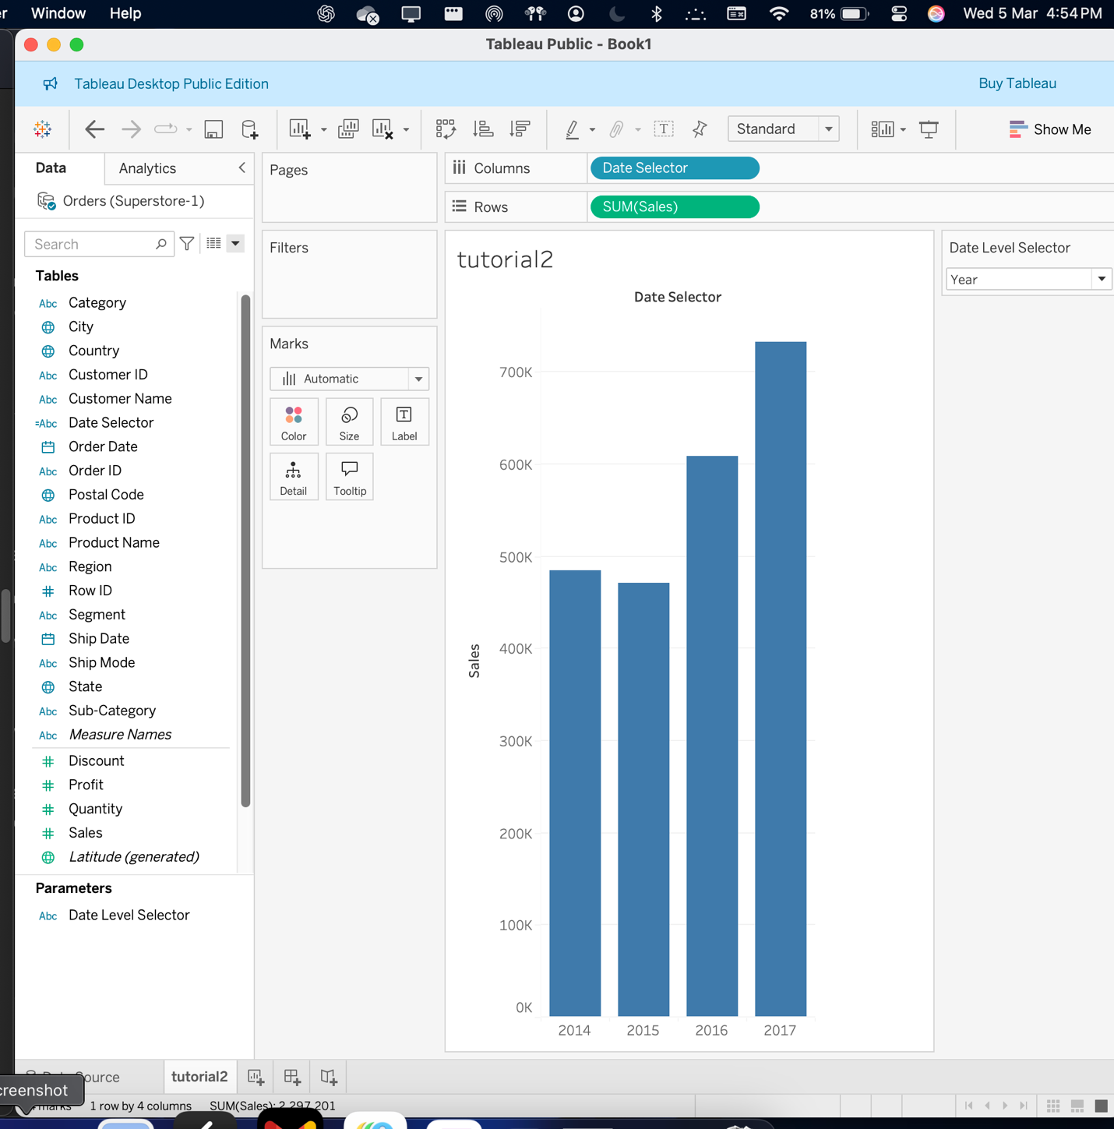

Step 7 : changing the mark type to line , transforming into a line chart.

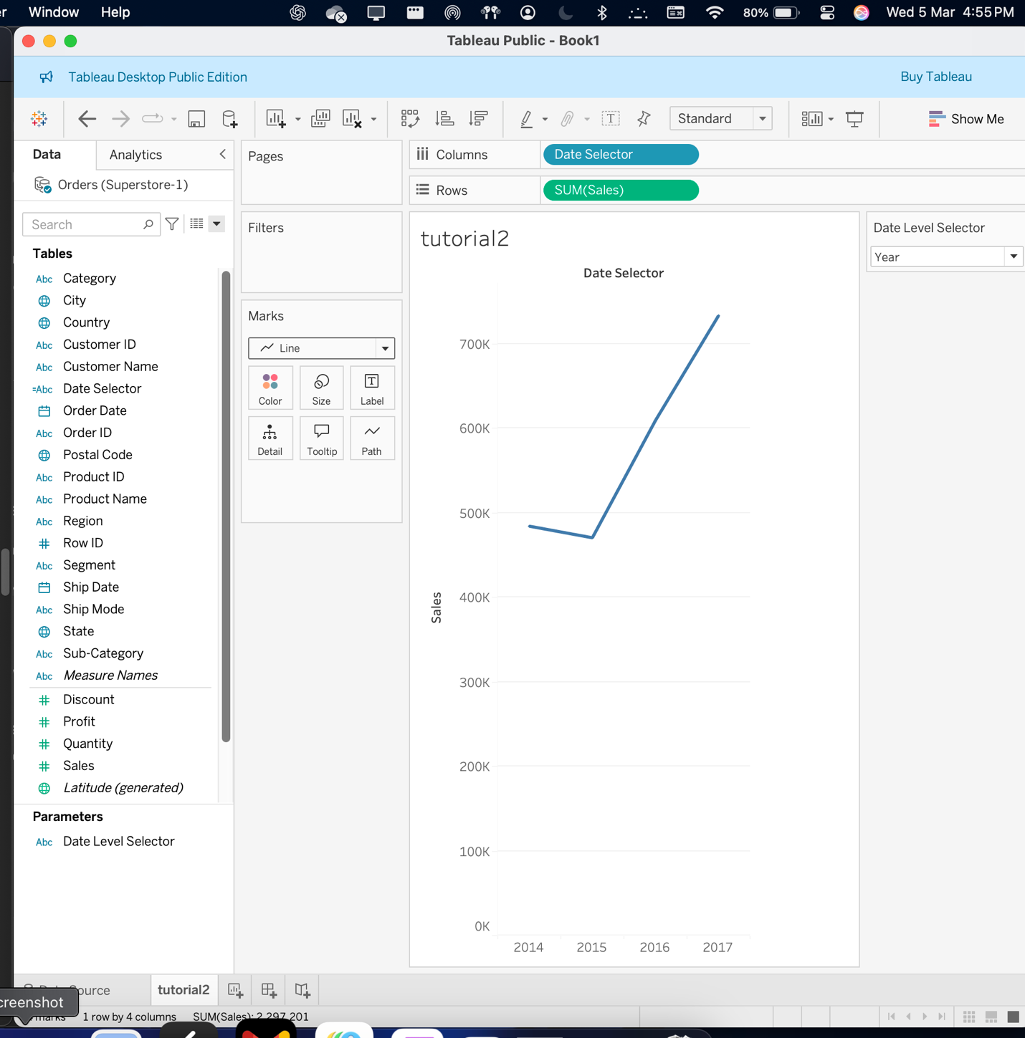

Step 8 : changing the customized date selector values to quarter to be able to display the data in months.

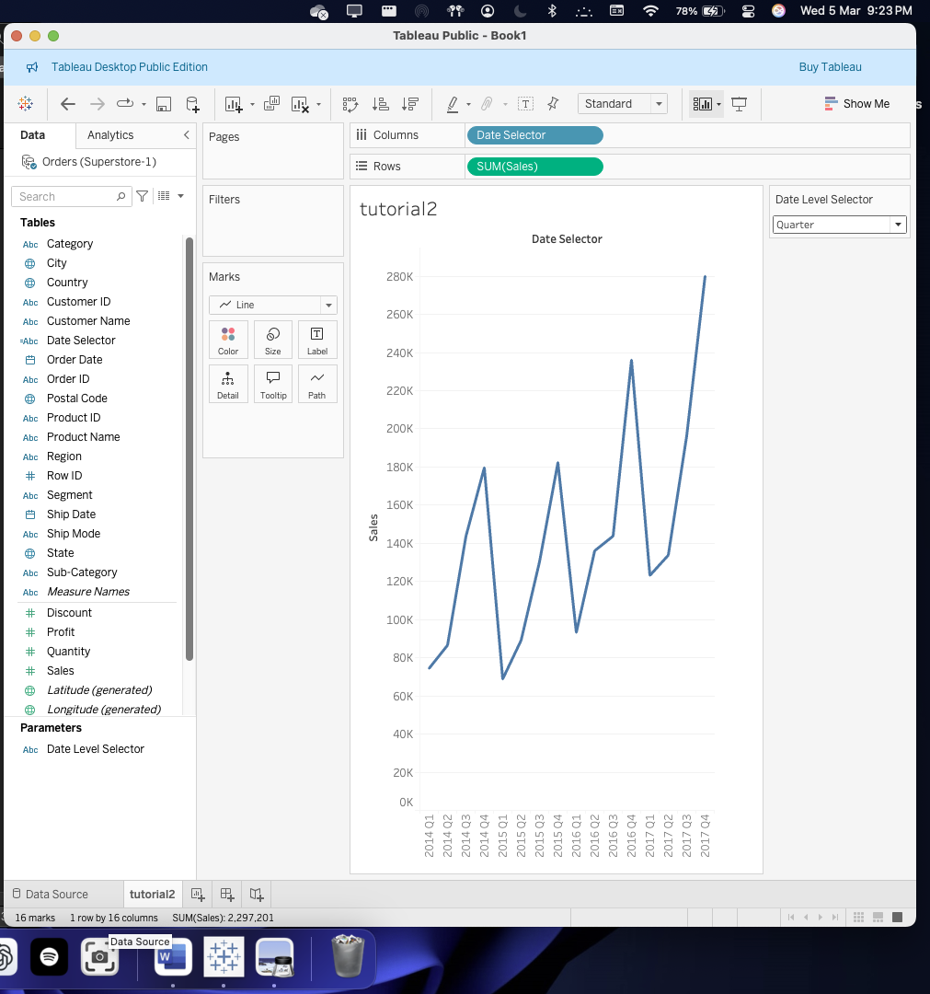

Step 9 : similarly we’re here changing the date level to months now .

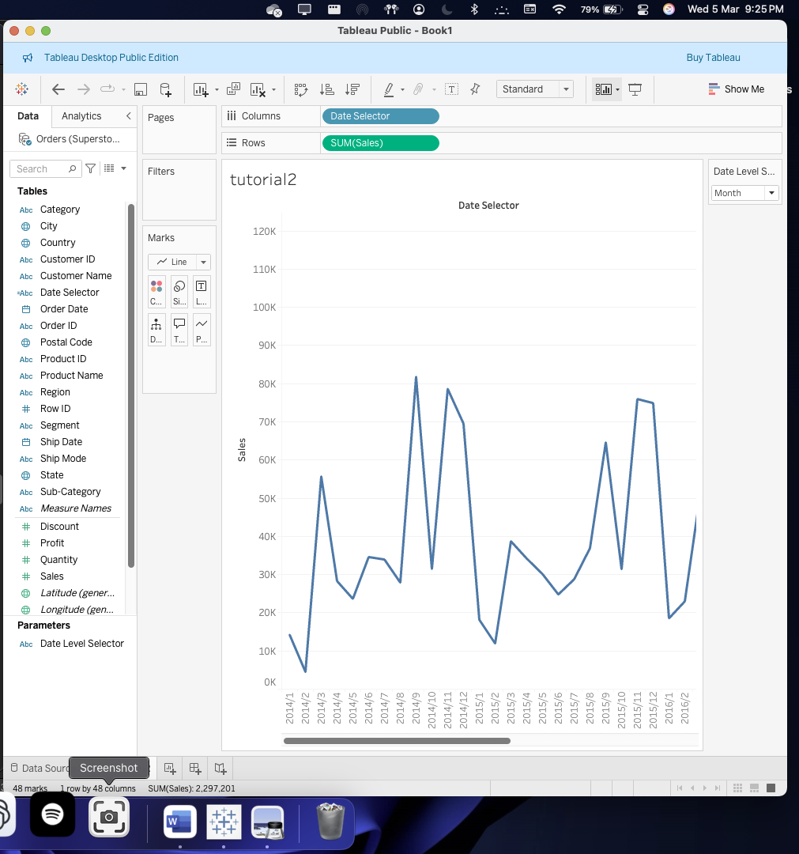

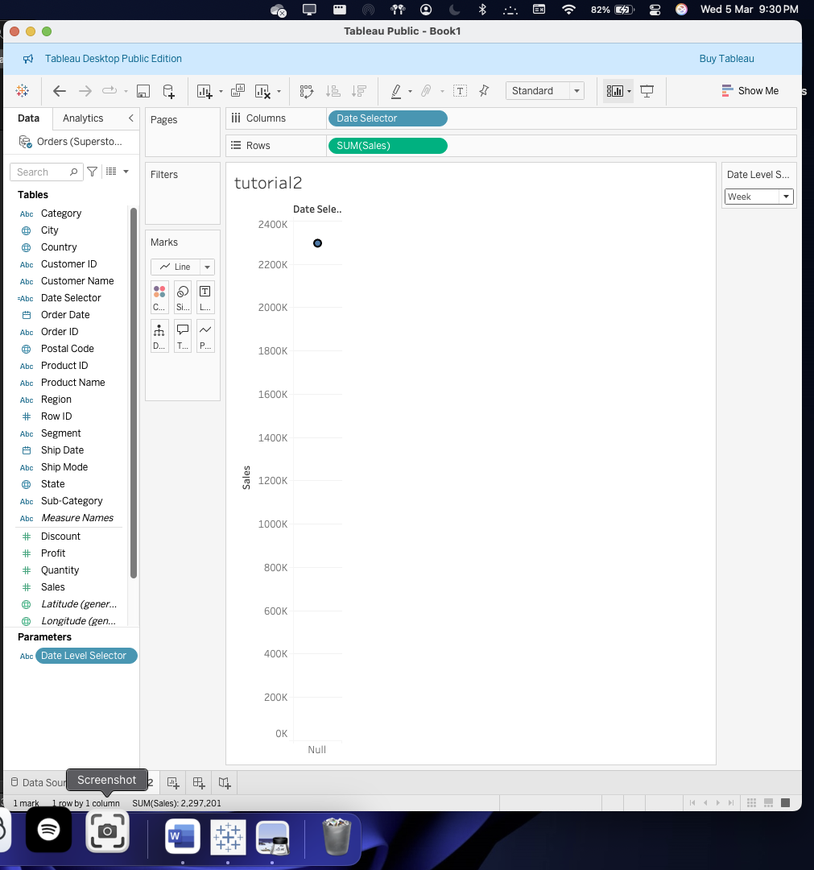

Question 2 :

1. Create a new parameter called as Sales Growth Rate

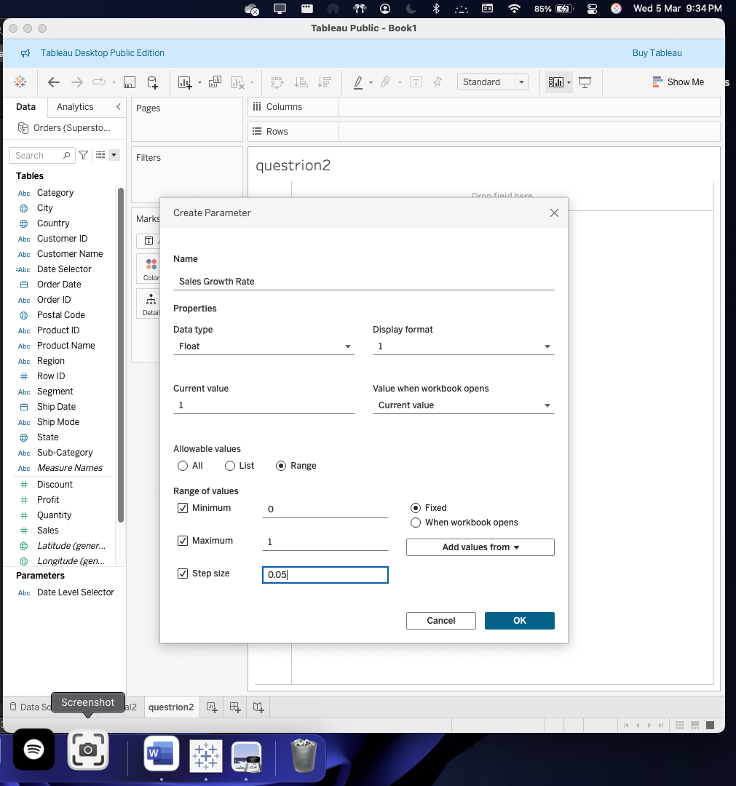

2. created a new field called as Adjusted Sales

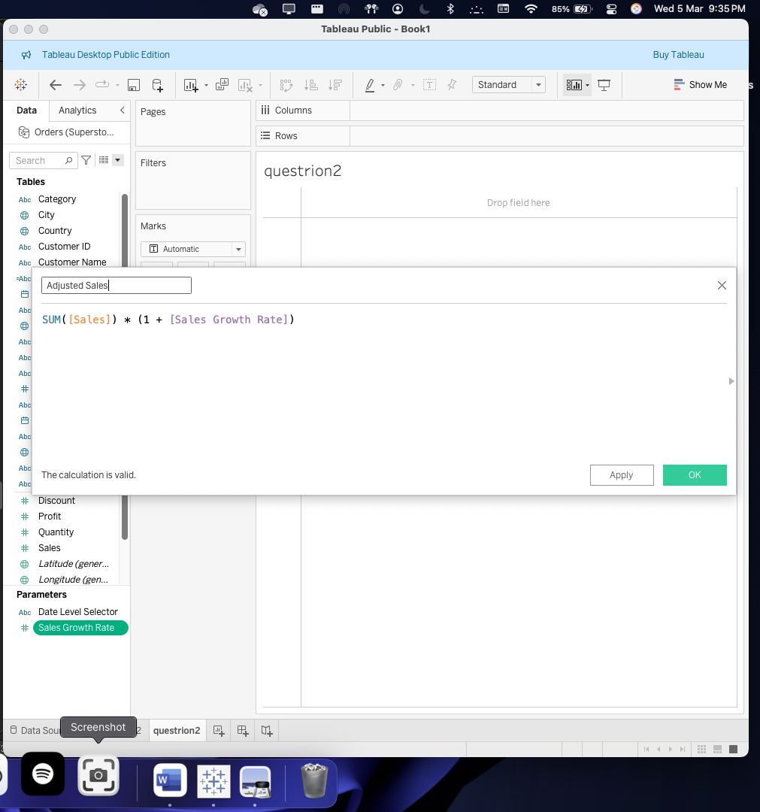

I had applied to show ‘Date level parameters and also the sales growth rate filters to visualize them in ‘years’ , ‘quarters’, ‘months’,’weeks’.

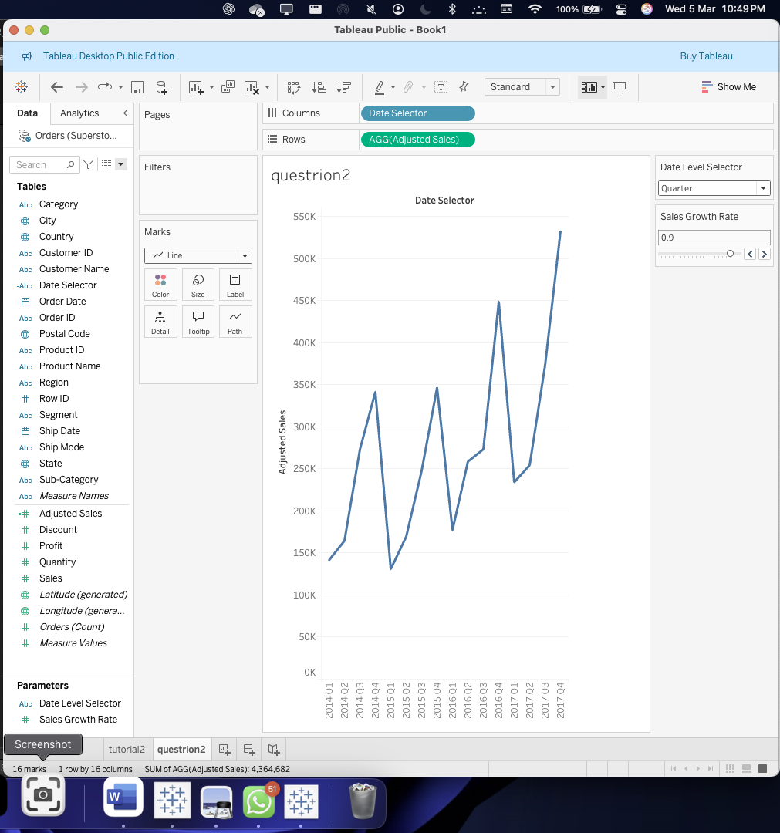

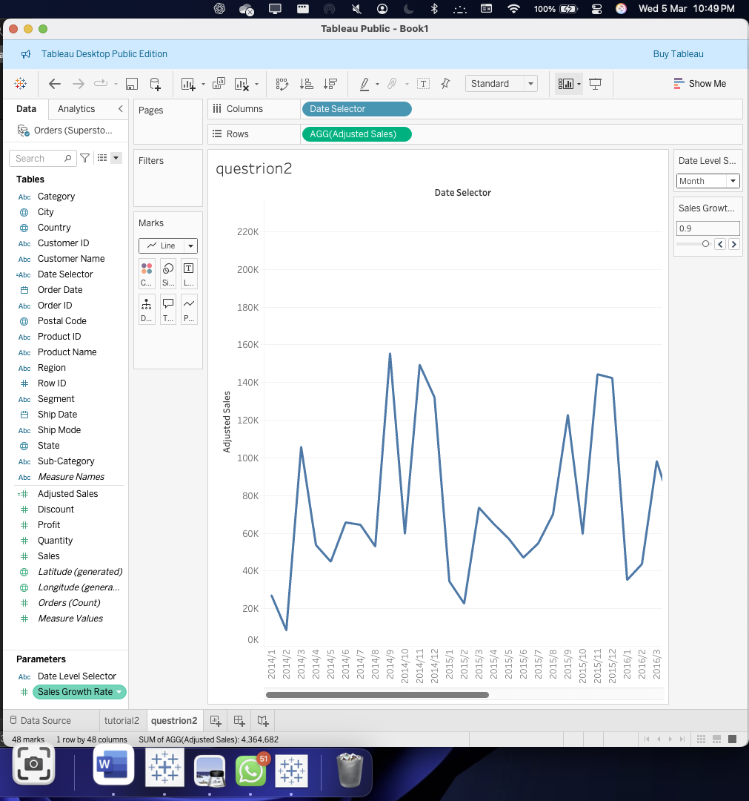

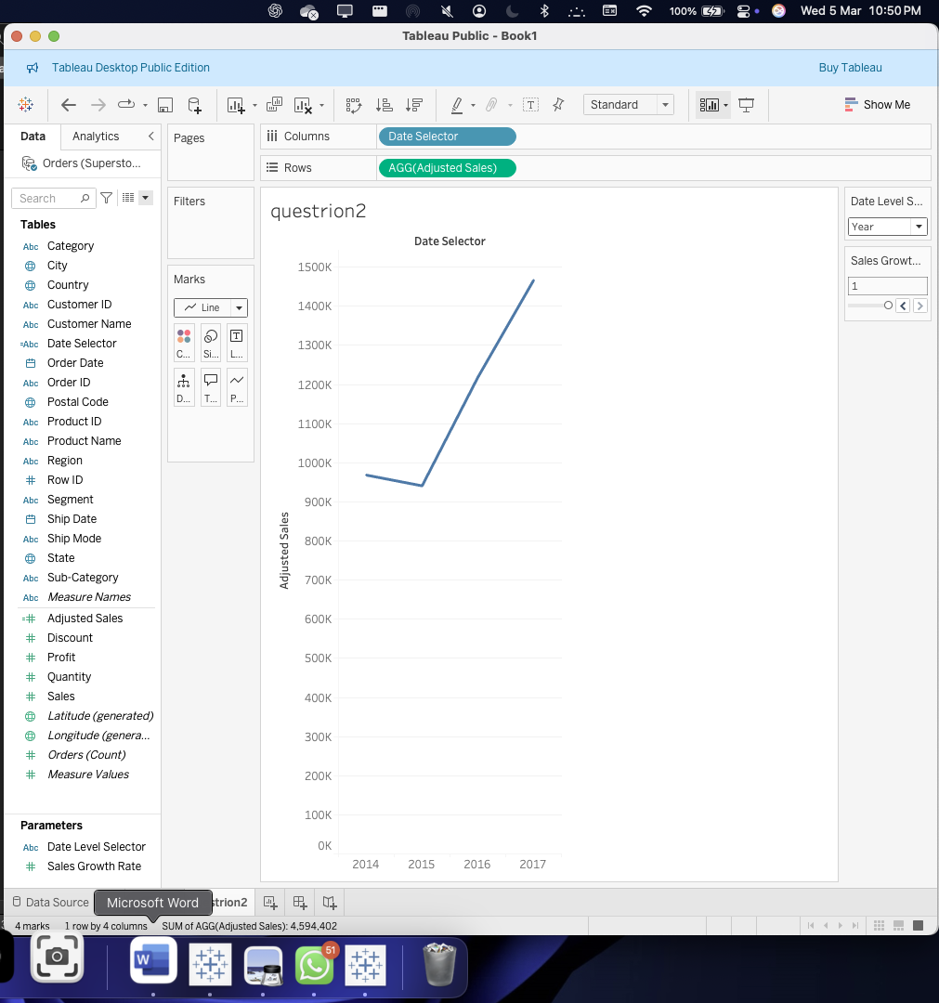

Question 2.5

Analyzation : Dynamic analysis of the trends(sales) on different growth assumptions and time periods.

1. Basically this visualization will allows us to have a track on the adjusted sales over the time .
2. By able to switch between ‘year’ , quarters and months , this can be able to analyze the different patterns of trends over the time or different granularities.
3. Sales growth rate , a new added parameter over here would help us see how the sales would change under various assumptions over the rate between 0 and 1 .

Task 3 :

Key performance indicator.

Step 1 :using the superstore dataset and then creating a new worksheet :

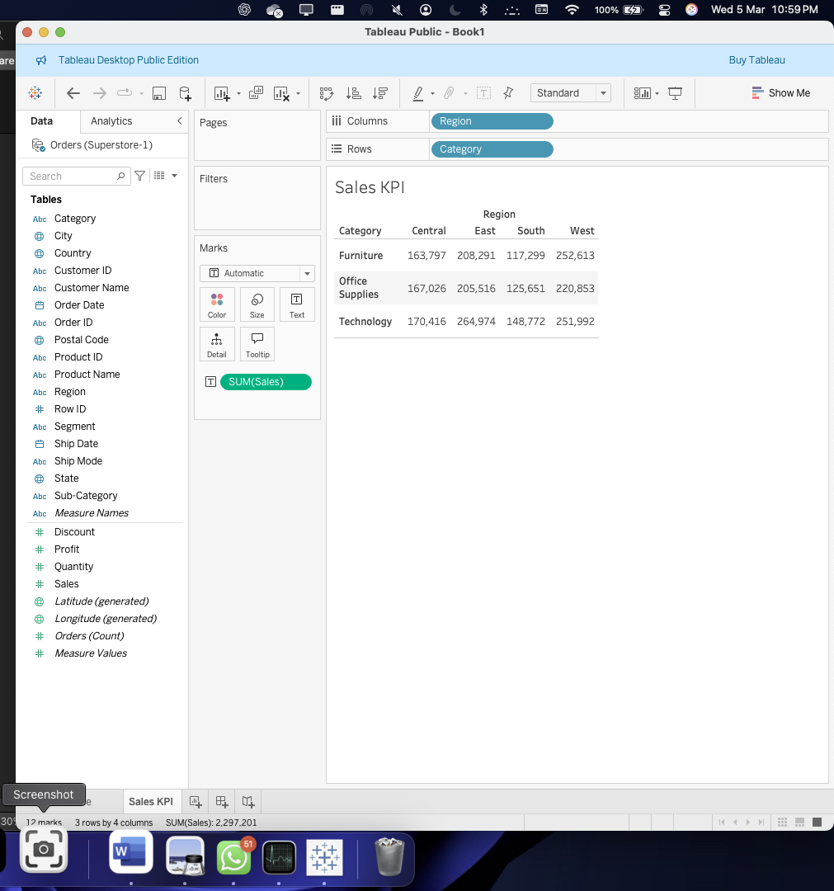

Step 2 : creating a calculated field accordingly . 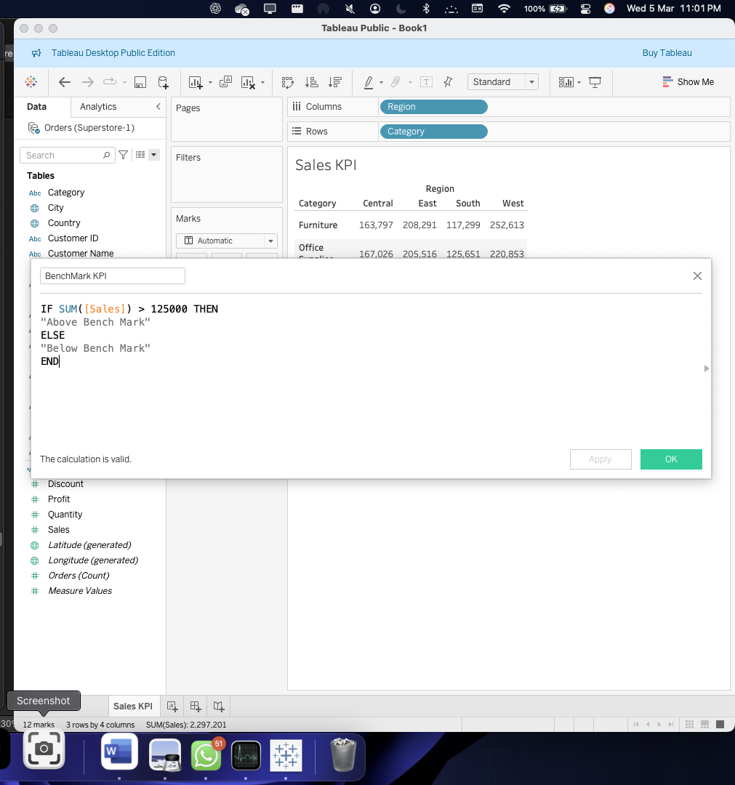

Step 3 : dragging the calculated field to the color shelf which gives us the values with a color showing us which and which are above and below the bench ( the value) / the threshold we have set up .

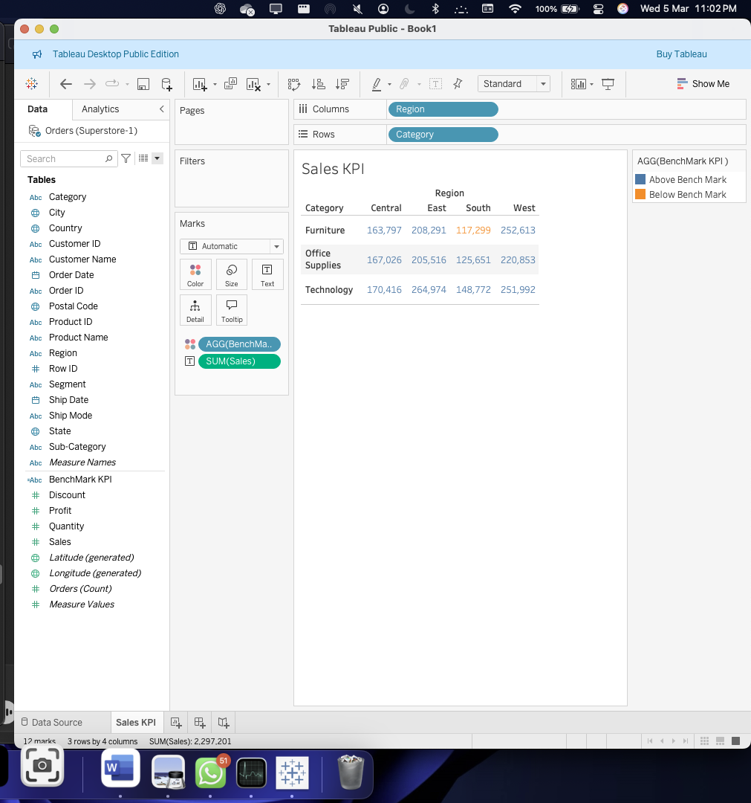

Step 4 : customizing the colors

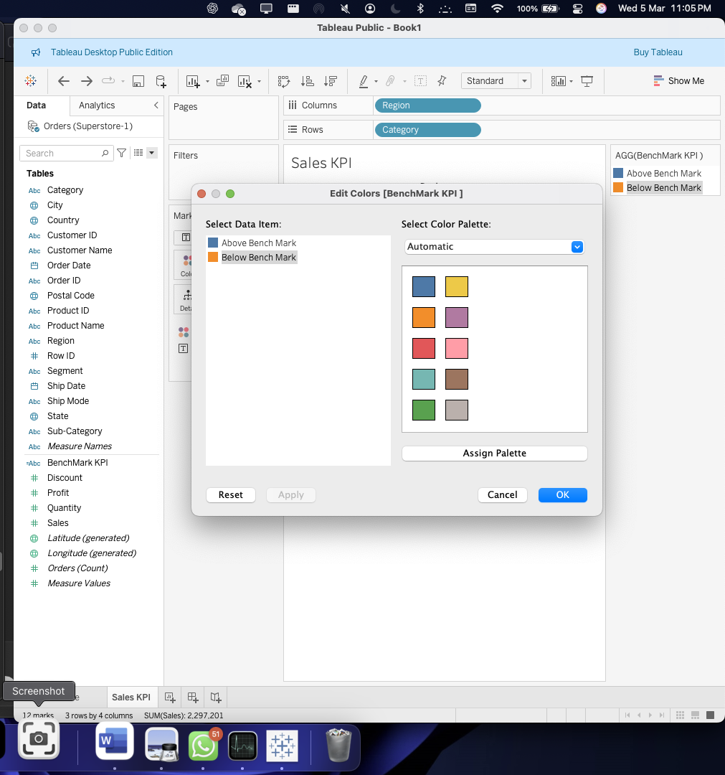

Step 5 : changing the mark type to shape :

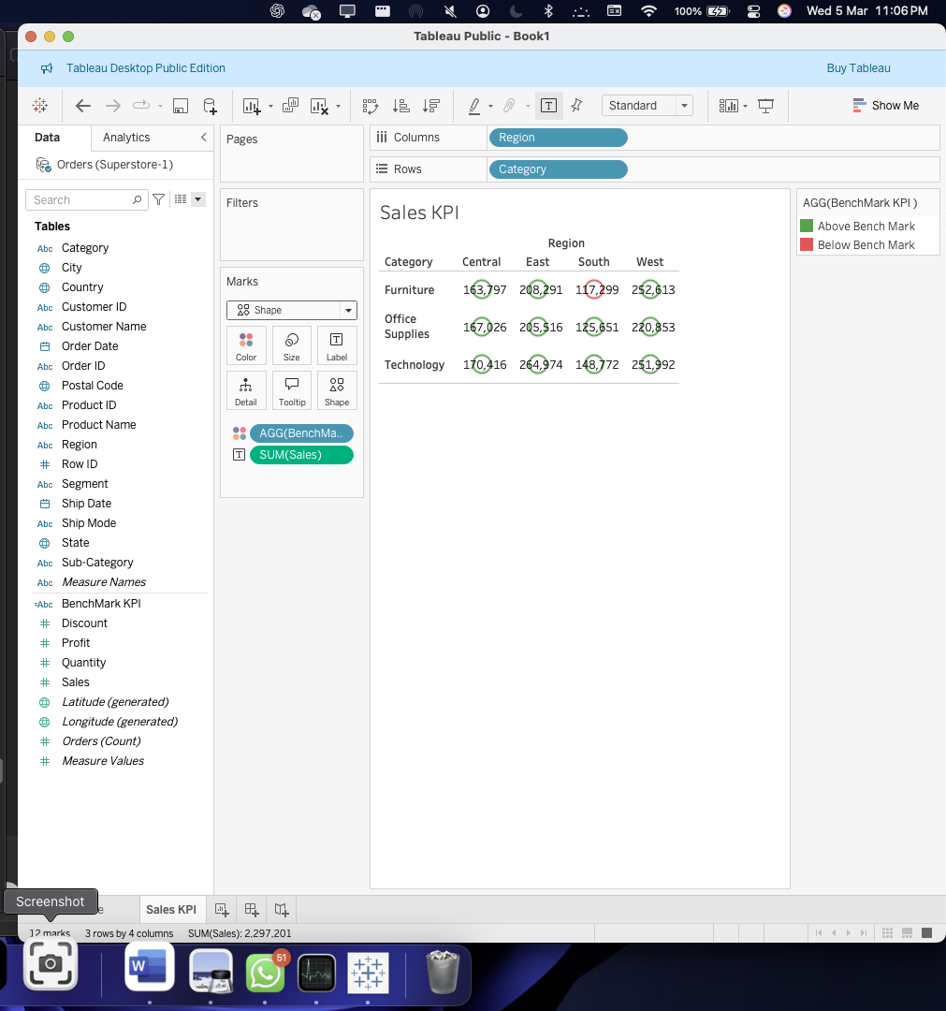

Step 6 :

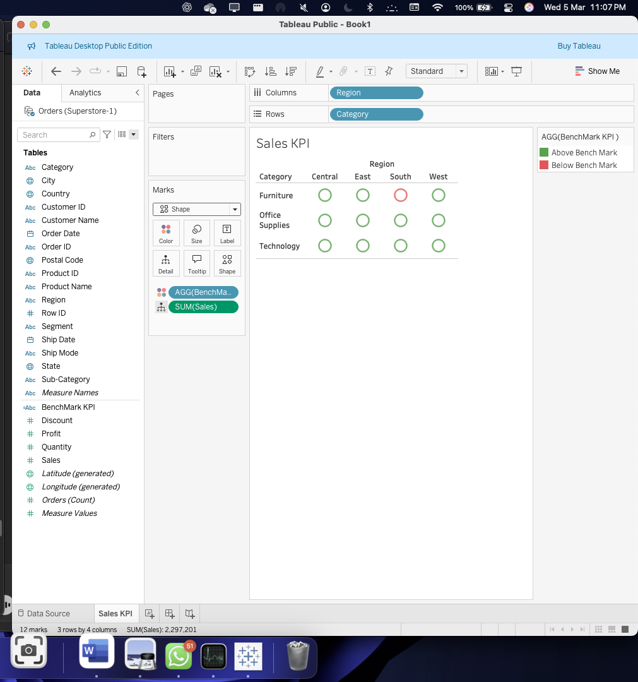

Step 7 : more customization using shapes .

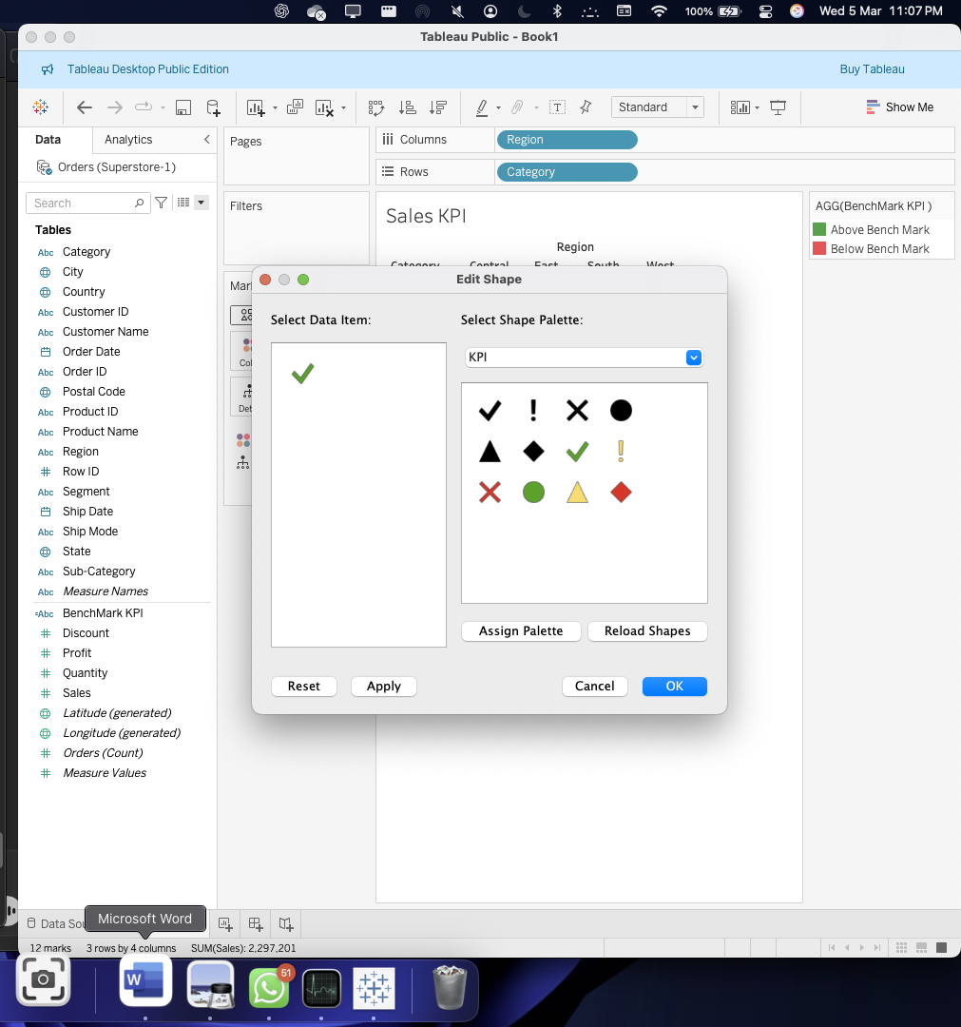

Step 8 : we can spot that the furniture has been underperforming in the south region .

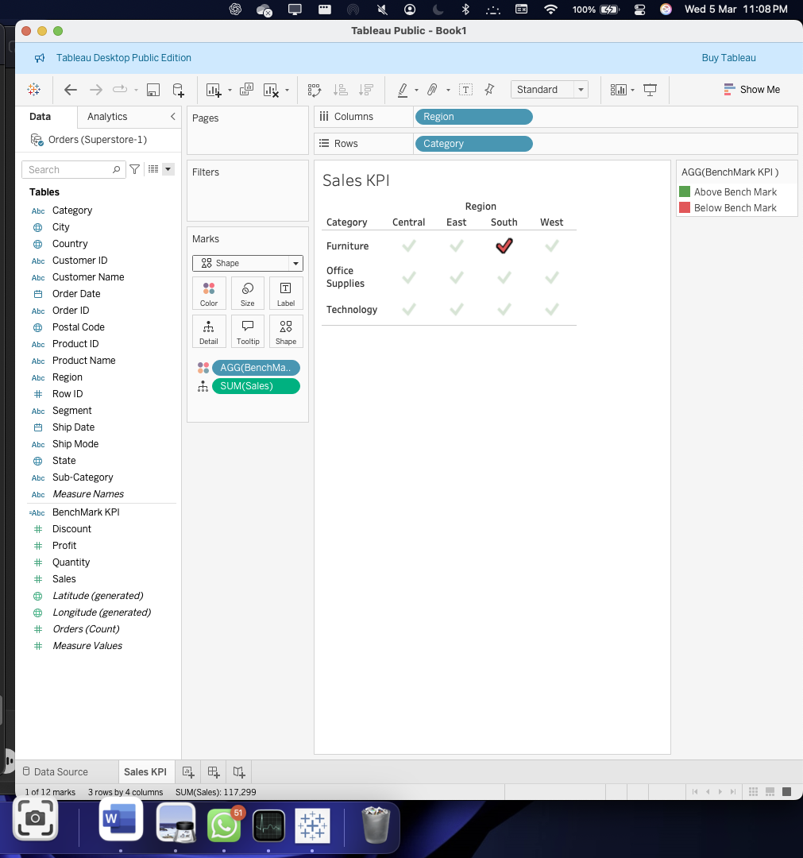

Question 3 :

1. Placing the given values

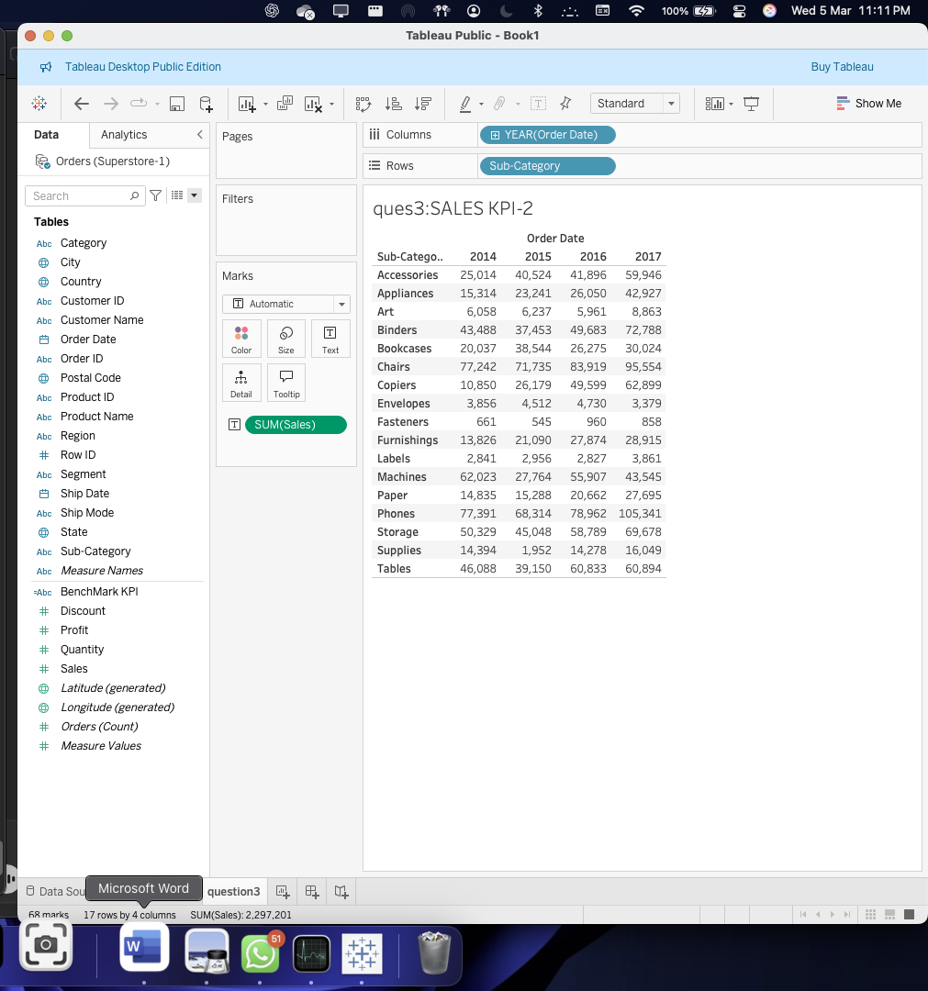

2. evaluation of the performance :

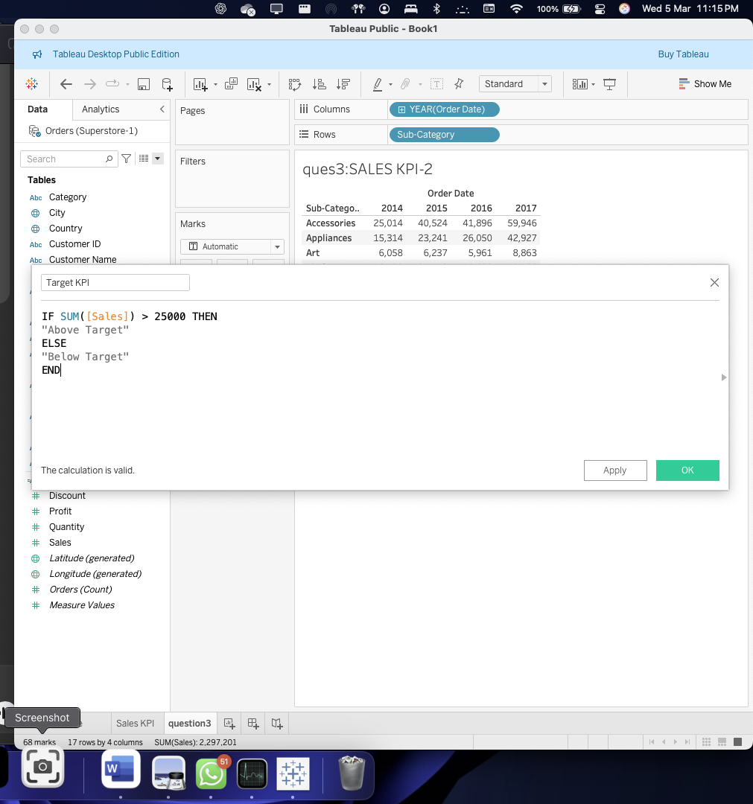

Function has been displayed with the values above and below are being displayed.

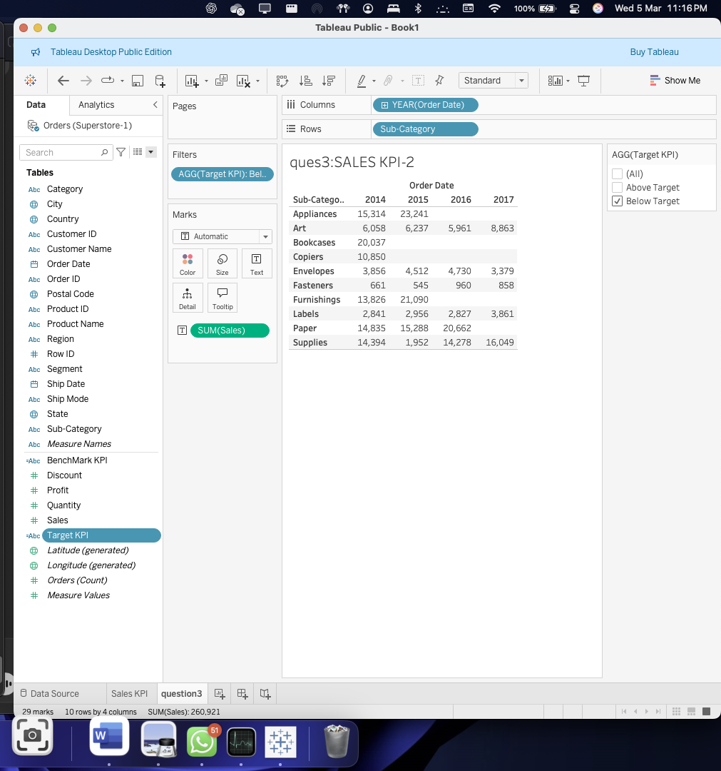

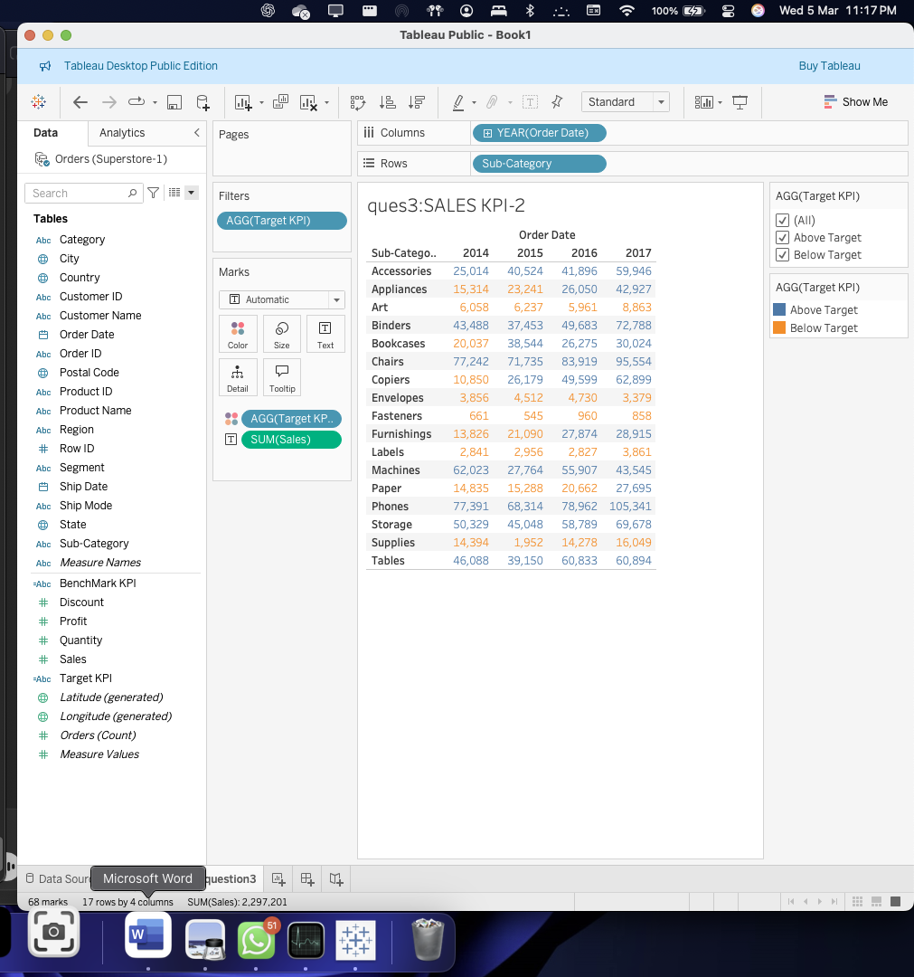

Question 3 : changing the shapes to the given values

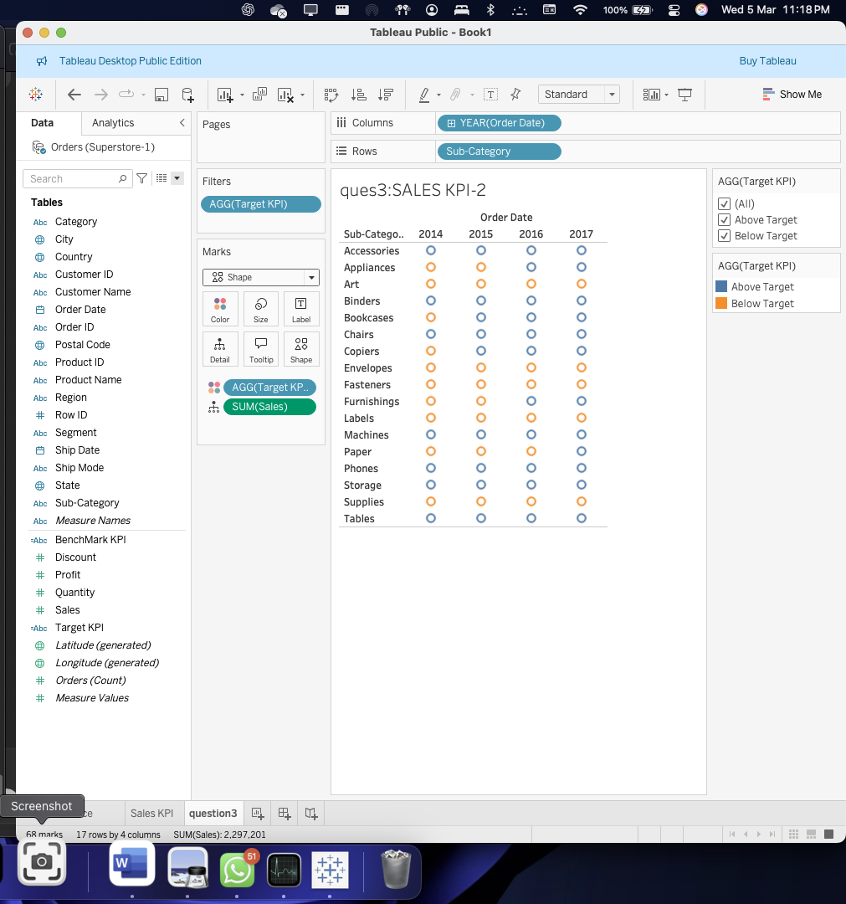

Question 4 :

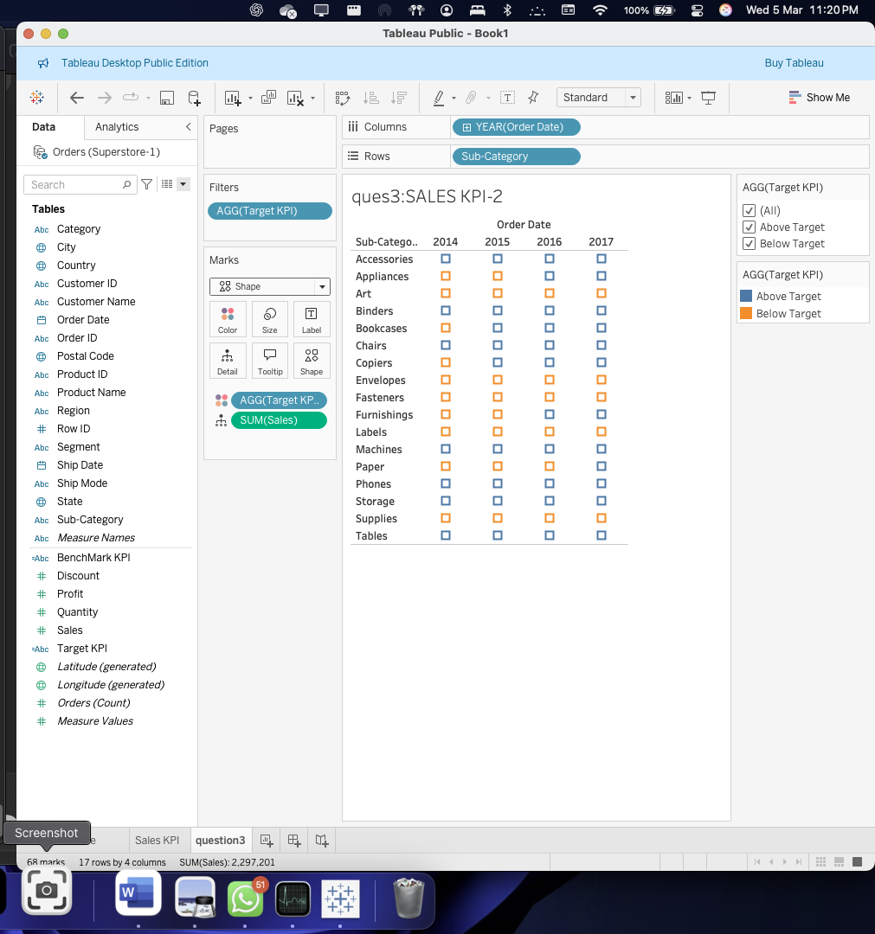

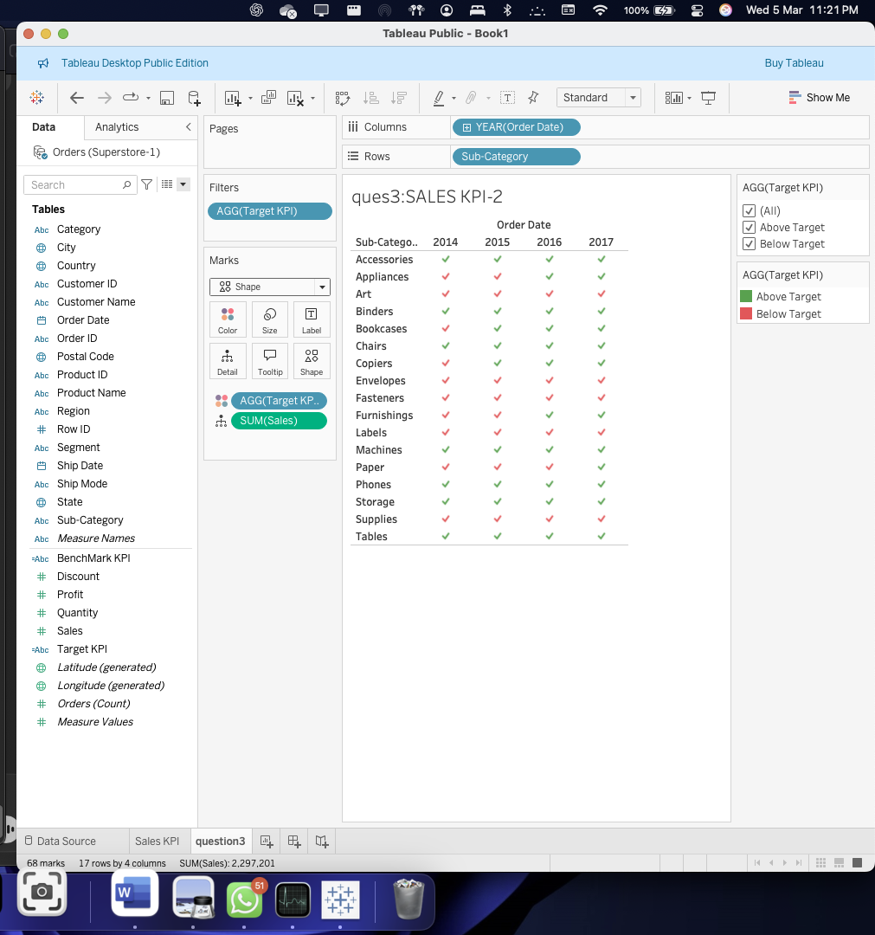

Question 5 :

Analyzation :

1. This visualization shows us with the performance of the subcategories of data which is based on the sales that had happened across years 2014 and 2017 .
2. Here ,each category is listen as rows and the years are being represented in the columns .
3. The kpi performance has been visually indicated using the checkmarks as asked .

Observations :

1. Consistent high performance has been recorded for some categories like the phone , tables and chairs etc with a recording high sales performance.
2. There has been performance drops for categories like the copiers and bookcases and binders which has affected their overall sales.
3. Some had fallen consistently below their set target like “fasteners , labels and envelopes “ which fail to meet their criteria showing it’s issues like low in demand.
4. Overall it’s a mix of above and below target performance.